Short term plan: term 1-3

Unit: Our World |  | Lesson 1
Teacher name: Zhexenbina A.A |  | School of Oriental Studies at Kazakh National University named after al-Farabi
Date: 05/09/2023
Grade: 8 Б |  | Number present: | absent:
Lesson title | Vocabulary: Entertainment
Learning objectives | 8.1.1.1 use speaking and listening skills to solve problems creatively and cooperatively in groups  8.5.5.1 develop with support coherent arguments supported when necessary by examples and reasons for a growing range of written genres in familiar general and curricular topics  8.2.7.1 recognise typical features at word, sentence and text level of a growing range of spoken genre
Lesson objectives | Learners will be able to:  - present forms of entertainment  - express an opinion  - talk about a past experience
Value links | Family – Family values are moral and ethical principles of typical family life, including sacrificing for loved ones, putting your loved ones first, and keeping your loved ones at the centre of your thoughts and actions.
Plan

Stages / Time | Teachers actions | Students actions | Assessment criteria | Resources
Beginning of the lesson  Warming-up  3 min.  Pre-learning  «Brainstorming» method  7 min. | Organization moment :  1.Greeting.  Ask about the weather.  The teacher sets the lesson objectives, letting students know what to anticipate from the lesson.  Warming up  Where are you from?  How old are you?  What color is it?  How many students are there in class?  What day of the week today?  Hand out the completed Progress Report Cards for the previous module and ask the pupils to file them in their language.  Lead – In | The aim: To develop pupils speaking skills and create friendly atmosphere  Efficiency: By wishing each other they feel better and feel the support of others  Students of the class are listed.  Students' attention is drawn to the lesson.  Students say different words from the picture  •Learners remember previous lesson vocabulary  •Learners answer the questions  What time do you get up every morning?  What time do you go to school?  What do you do after the lesson? | The teacher to assess learners for their ability.  “Good job!  Well done!”  Formative Assessment  Good job!  Descriptor:  - remembers the lesson passed  Point 1  Assessment criteria  make basic statements related present forms of entertainment | Pictures  worksheet  Picture
Middle of the lesson  Presentation part.  30 min | Ex:1 P:29  • Direct Ss to the pictures.  • Play the recording. Ss listen and repeat chorally and/or individually.  Ex: 2 P: 29  • Ask Ss to discuss the questions in pairs.  • Monitor the activity around the class and then ask various Ss to tell the class.  Ex: 3 P: 29  • Read out the questions and the example.  • Ask Ss to discuss the questions in pairs. Elicit suitable adjectives from Ss around the class (e.g. nice, fun, exciting, amazing, entertaining, etc).  • Then ask various Ss to tell the class.  Conclusion during the lesson some tasks differentiated by outcomes of the students and by their abilities. | • Learners look at the pictures  ANSWERS  Students own answer  • Learners answer the question. Use the adjectives below.  ANSWERS  I like attending concerts because I love music and the atmosphere at a concert is fascinating.  • Learners answer the question. Tell the class.  ANSWERS  The last time I watched traditional dancing was last summer. It was nice. The last time I went to a water park was two summers ago. It was great fun. The last time I took a guided tour of a museum was two years ago. It was interesting. The last time I attended a concert was last month. It was amazing.  The last time I read a classic novel was 3 years ago. It was interesting. The last time I went to the theatre was two weeks ago. It was entertaining | Descriptor:  - look at the pictures.  - listen and repeat chorally and/or individually.  Total: 3 point  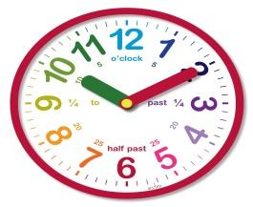  Self assessment  Differentiation: «Verbal support» method is used to help Ss use new words in the sentences.  Descriptor:  - answer the question. Use the adjectives below  Total: 3 point  Descriptor:  - answer the question. Tell the class  Total: 3 point  -Make CCQ questions Yes / No | Card  Worksheet  Students book
End of the lesson  5 min | FEEDBACK  Learners provide feedback on what they have learned at the lesson.  Ex: P:  Home task:  Write the days | 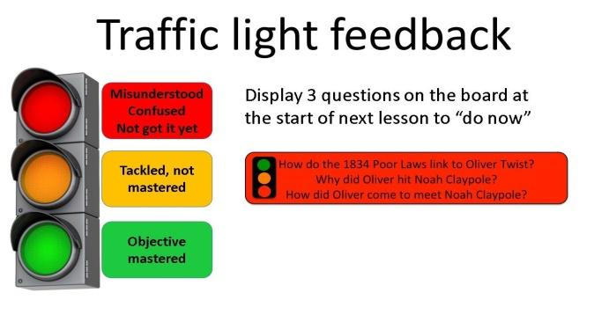 |  | Poster Success

Unit: Family, relations with other people, personal identification; personal feelings, experiences and opinions |  | Lesson 2
Teacher name: Zhexenbina A.A |  | School of Oriental Studies at Kazakh National University named after al-Farabi
Date: 12.09-19.09.2024
Grade: 8 Б |  | Number present: | absent:
Lesson title | Reading: Steve’s travel blog
Learning objectives | 8.3.2.1 ask more complex questions to get information about a growing range of general topics and some curricular topics  8.6.2.1 use a growing variety of quantifiers for countable and uncountable nouns including several, plenty, a large/small number/amount on a range of familiar general and curricular topics  8.1.9.1 use imagination to express thoughts, ideas, experiences and feeling
Lesson objectives | Learners will be able to:  - To introduce the topic and topic-related vocabulary  - read for specific information  - learn about and identify compound nouns and compound adjectives
Value links | Loyalty – Loyalty might be a core personal value to you if you highly prize friends that are reliable and trustworthy. You might put your friends or chosen family first, always being there for them when they need you.
Plan

Stages / Time | Teachers actions | Students actions | Assessment criteria | Resources
Beginning of the lesson  Warming-up  3 min  Pre-learning  «Brainstorming» method  7 min. | Organization moment :  1.Greeting.  Ask about the weather.  The teacher sets the lesson objectives, letting students know what to anticipate from the lesson.  Warming up  Where are you from?  How old are you?  What color is it?  How many students are there in class?  What day of the week today?  Ask a few pupils to stand up and stand in a row. Ask the rest of the class questions to revise the ordinals.  Lead – In | The aim: To develop pupils speaking skills and create friendly atmosphere  Efficiency: By wishing each other they feel better and feel the support of others  Students of the class are listed.  Students' attention is drawn to the lesson.  Determines the topic and purpose of the lesson  •Learners remember previous lesson vocabulary  Students say different words from the picture  Answer the question. | The teacher to assess learners for their ability.  “Good job!  Well done!”  Formative Assessment  Good job!  Descriptor:  - know daily routines vocabulary  - know prepositions of place  Point 1  Assessment criteria  - Learners have met the learning objectives if they can talk about beautiful places | Pictures  worksheet  Student’s book
Middle of the lesson  Presentation part.  30 min | Ex:1 P:30  • Ask Ss to look at the pictures and then read out the activities in the list.  • Ask various Ss to say which activities they can do in each place.  • Play the recording. Ss listen and read the text and check.  Ex: 2 P: 31  • Explain the task.  • Allow Ss time to read the questions and then read the texts again and complete the task.  • Check Ss’ answers.  Ex: 3 P: 31  • Allow Ss time to complete the collocations by referring to the texts or using their dictionaries as necessary.  • Check Ss’ answers around the class.  Ex: 4 P: 31  • Read the table aloud and explain compound nouns and adjectives and elicit further examples from Ss around the class.  • Give Ss time to find examples in the blog.  • Check Ss’ answers. | • Pupils look at the places in the pictures. Answer the question.  ANSWERS  You can have a fun water experience in all the places.  You can take a dip in a pool and slide down a waterslide at Almaty Aqua Park.  You can relax in a mineral spring at Chundzha.  You can play on a sandy beach at Khan Shatyr.  • Pupils read the text again and answer the question.  ANSWERS  1 You can find an indoor beach.  2 It comes from the Maldives. 3 They can swim in the pool and go on the waterslides.  4 There are more than 140.  5 It is a five-hour drive  • Pupils complete the collocations.  ANSWERS  1 summer  2 entertainment  3 tropical  4 aqua  5 mineral  6 indoor  Pupils read the theory. Find compound nouns and compound adjectives.  ANSWERS  Compound nouns: entertainment centre, indoor beach, aqua park  Compound adjectives: two-week holiday, five-hour drive | Descriptor:  - look at the places in the pictures  - answer the question.  Total: 2 point  pupils are evaluated by collecting fish  Descriptor:  - read the text again  - answer the question  Total: 1 point  Descriptor:  - complete the collocations.  Total: 2 point  Self assessment  -Make CCQ questions Yes / No  Total: 10 point | Card  Worksheet  Students book
End of the lesson  5 min | FEEDBACK  Learners provide feedback on what they have learned at the lesson.  Ex: P:  Home task:  Write the days | 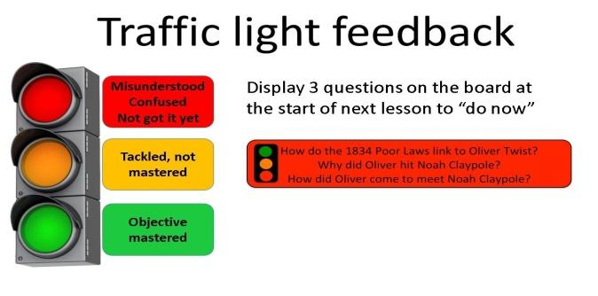 |  | Poster Success

Unit: House and Homes |  | Lesson 3
Teacher name: Zhexenbina A.A |  | School of Oriental Studies at Kazakh National University named after al-Farabi
Date: 26.09.2023
Grade: 8 Б |  | Number present: | absent:
Lesson title | Vocabulary: water experiences
Learning objectives | 8.4.8.1 use familiar and some unfamiliar paper and digital reference 8.2.2.1 understand with little or no support most specific information in extended talk on a wide range of general and curricular topics  esources to check meaning and extend understanding  8.3.7.1 use appropriate subject-specific vocabulary and syntax to talk about a range of general topics, and some curricular topics
Lesson objectives | Learners will be able to:  - present new vocabulary  - talk about water attractions
Value links | Fairness – If you value fairness, you might be highly sensitive to situations at school or in the workplace where a teacher or a peer has exhibited favoritism or allowed someone to get away with living by a different set of rules to everyone else.
Plan

Stages / Time | Teachers actions | Students actions | Assessment criteria | Resources
Beginning of the lesson  Warming-up  3 min  Pre-learning  «Brainstorming» method  7 min. | Organization moment :  1.Greeting.  Ask about the weather.  The teacher sets the lesson objectives, letting students know what to anticipate from the lesson.  Warming up  Where are you from?  How old are you?  What color is it?  How many students are there in class?  What day of the week today?  revise the vocabulary from the previous  Lead – In  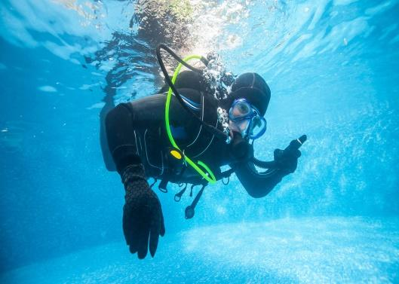 | .  The aim: To develop pupils speaking skills and create friendly atmosphere  Efficiency: By wishing each other they feel better and feel the support of others  Students of the class are listed.  Students' attention is drawn to the lesson.  • Learners remember previous lesson vocabulary  Determines the topic and purpose of the lesson  Students say different words from the picture | The teacher to assess learners for their ability.  “Good job!  Well done!”  Formative Assessment  Good job!  Descriptor:  - can tell the time  Point 1  Assessment criteria  - Learners have met the learning objectives if they can talk about water attractions | Pictures  worksheet  Picture
Middle of the lesson  Presentation part.  30 min | Ex: 5 P: 31  • Read through the list of prepositions and give Ss time to complete the sentences using their dictionaries to check.  • Check Ss’ answers.  Ex:6 P: 31  • Read out the list of words give Ss time to complete the sentences using their dictionaries if necessary. • Check Ss’ answers.  Ex: 7 P: 31  • Give Ss some time to consider their answers and then ask various Ss to tell the class.  Ex: 8 P: 31  • Ask Ss to read the useful language box and have two Ss model the example dialogue.  • Then have Ss take turns and practise recommending the places in the blog in pairs.  • Monitor the activity around the class and then ask some pairs to practise recommending in front of the class using the useful language  Conclusion during the lesson some tasks differentiated by outcomes of the students and by their abilities. | •Pupils complete the sentences. Use for, about or on  ANSWERS  1 on  2 on  4 about  3 for  5 on  6 for  •Pupils fill the gaps.  ANSWERS  1 sandy  2 dip  3 slide  4 sunbathe  5 sailing  •Pupils answer the question. Tell the class.  ANSWERS  Suggested Answer Key Khan Shatyr is special because it has an indoor beach with sand from the Maldives. Almaty Aqua Park is special because it is a fun water park with lots of waterslides for adults and children. Chundzha is special because it has over 140 mineral springs  •Pupils use the phrases to recommend the places in the text in Ex 1  ANSWERS  A: Have you been to the indoor beach at Khan Shatyr?  B: Yes, I went there last summer.  A: Did you like it?  B: It was great. | Descriptor:  - complete the sentences  -use prepositions  Total: 1 point  Descriptor:  - fill the gap  Total: 1 point  Descriptor:  - answer the question  Total: 1 point  Descriptor:  - use the phrases to recommend the places  Total: 1 point  -Make CCQ questions Yes / No  pupils are evaluated by collecting pencils | Card  Worksheet
End of the lesson  5 min | FEEDBACK  Learners provide feedback on what they have learned at the lesson.  Ex:  Home task: |  |  | Poster Success

Unit : Creating a Personal Profile |  | Lesson 4
Teacher name: Zhexenbina A.A |  | School of Oriental Studies at Kazakh National University named after al-Farabi
Date: 03.10.2023
Grade: 8 Б |  | Number present: | absent:
Lesson title | Use of English: Past simple, Past continuous
Learning objectives | 8.5.2.1 write with minimal support about real and imaginary past events, activities and experiences on a range of familiar general topics and some curricular topics  8.3.6.1 link comments with some flexibility to what others say at sentence and discourse level in pair, group and whole class  8.6.7,1 use a variety of simple perfect forms to express recent, indefinite and unfinished past on a range of familiar general and curricular topics
Lesson objectives | Learners will be able to:  - revise/present the past simple and the past continuous and identify their uses  - practise the past simple/past continuous  - practise the past simple/past continuous with time adverbs
Value links | Honesty – You may highly value telling people the truth. This one gets tricky when being honest can be hurtful to others. So, a person who really puts honesty first might be the sort of person who will tell the truth even if it hurts to do so.
Plan

Stages / Time | Teachers actions | Students actions | Assessment criteria | Resources
Beginning of the lesson  Warming-up  3 min  Pre-learning  «Brainstorming» method  7 min. | Organization moment :  1.Greeting.  Ask about the weather.  The teacher sets the lesson objectives, letting students know what to anticipate from the lesson.  Warming up  Where are you from?  How old are you?  What color is it?  How many students are there in class?  What day of the week today?  revise the language from the previous lesson  Lead – In  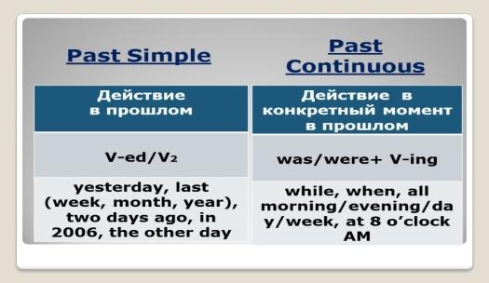 | The aim: To develop pupils speaking skills and create friendly atmosphere  Efficiency: By wishing each other they feel better and feel the support of others  Students of the class are listed.  Students' attention is drawn to the lesson.  • Learners talk about daily routines previous lesson vocabulary  Determines the topic and purpose of the lesson  Students say different words from the picture | The teacher to assess learners for their ability.  “Good job!  Well done!”  Formative Assessment  Good job!  Descriptor:  - talk about daily routines  Point 1  Assessment criteria  - Learners have met the learning objectives if they can talk about | Pictures  worksheet  Student’s book
Middle of the lesson  Presentation part.  30 min | Ex:1 P:32  • Present the past simple. Say then write on the board: I watched TV yesterday. Underline watched and explain that this verb is in the past simple. Point to a S and say: You watched TV yesterday. Then write it on the board. Point to a male S and say: He watched TV yesterday. Then write it on the board. Present the other persons in the same way. Elicit that the verb is the same in all persons.  •Explain/Elicit the spelling rules. Write the verbs work, love, play, study, travel and their past simple forms on the board: work – worked (most verbs take -ed to form their past simple form), love – loved (verbs ending in -e add -d), study – studied (verbs ending in consonant + -y lose -y and take -ied), play – played (verbs ending in a vowel + -y add -ed), travel – travelled (verbs ending in a vowel + l, p, k, b, etc. double the consonant and add -ed)  Ex: 2 P: 32  • Explain the task and give Ss time to complete it.  • Then check Ss’ answers around the class.  Ex: 3 P: 32  • Explain the task and read out the example.  • Give Ss time to complete the task in closed pairs.  • Monitor the activity around the class.  Ex: 4 b P: 32  • Ask Ss to read the theory box and elicit in which sentences we can write would instead of used to.  Conclusion during the lesson some tasks differentiated by outcomes of the students and by their abilities. | •Pupils read the text. Identify the tenses.  ANSWERS  1 past simple  2 past continuous  3 past simple  4 past simple  5 past continuous  6 past continuous  7 past continuous  8 past continuous  9 past simple  a past simple  e past continuous  b past simple  f past continuous/  c past continuous past simple  d past continuous  •Pupils put the verbs in brackets into the pasts simple or past continuous  ANSWERS  1 were you  2 was watching  3 did you see  4 was waiting  5 did Nurislam do  6 bought  7 went  8 Did you go  9 Was driving  10 got  •Pupils use the time adverbs to make sentences about yourself and your friends  ANSWERS  I went to the theatre last month. My friend Gulnar and I went on holiday in 2015. I was studying when you called me. Sezim was reading a book while I was listening to music. I stayed home last Saturday. I went to the cinema with Temir two days ago.  •Pupils complete with used to or would  ANSWERS  1 used to/would  2 used to  3 used to  4 used to/would  5 used to/would  6 used to/would | Descriptor:  - read the text  - identify the tenses  Total: 2 point  Descriptor:  - put the verbs in brackets into the pasts simple or past continuous  Total: 2 point  pupils are evaluated by collecting colour pencils  Descriptor:  - use the time adverbs to make sentences  Total: 3 point  Descriptor:  - complete with used to or would  Total: 3 point  -Make CCQ questions Yes / No  Total: 10 point | Card  Worksheet  Students book
End of the lesson  5 min | FEEDBACK  Learners provide feedback on what they have learned at the lesson.  Ex:  Home task: | 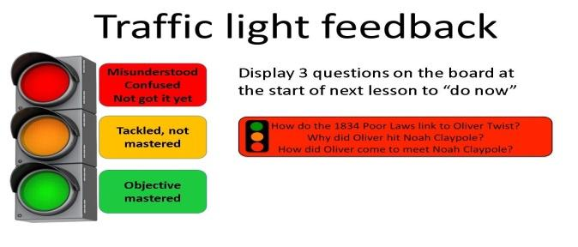 |  | Poster Success

Unit: Discussion on the role of social media |  | Lesson 5
Teacher name: Zhexenbina A.A |  | School of Oriental Studies at Kazakh National University named after al-Farabi
Date: 10.10.2023
Grade: 8 Б |  | Number present: | absent:
Lesson title | Use of English: Comparisons
Learning objectives | 8.1.1.1 use speaking and listening skills to solve problems creatively  and cooperatively in groups  8.3.7.1 use appropriate subject-specific vocabulary and syntax to talk about a range of general topics, and some curricular topics  8.2.2.1 understand with little or no support most specific information in extended talk on a wide range of general and curricular topics
Lesson objectives | Learners will be able to:  - practise used to/would  - practise word formation (-ing/-ed participles)  - practise making comparisons between films
Value links | Generosity – This may be a core value of yours if you cherish people who will give their time and resources to people in need. You may consider yourself to be a generous person if you find joy and meaning in giving to others.
Plan

Stages / Time | Teachers actions | Students actions | Assessment criteria | Resources
Beginning of the lesson  Warming-up  3 min  Pre-learning  «Brainstorming» method  7 min. | Organization moment :  1.Greeting.  Ask about the weather.  The teacher sets the lesson objectives, letting students know what to anticipate from the lesson.  Warming up  Where are you from?  How old are you?  What color is it?  How many students are there in class?  What day of the week today?  Revise the vocabulary from the previous lesson  Lead – In  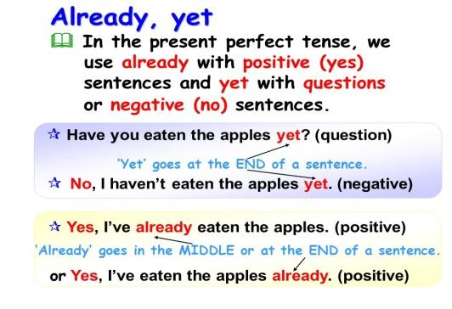 | The aim: To develop pupils speaking skills and create friendly atmosphere  Efficiency: By wishing each other they feel better and feel the support of others  Students of the class are listed.  Students' attention is drawn to the lesson.  • Learners talk about days of the week previous lesson vocabulary  Determines the topic and purpose of the lesson  Students say different words from the picture | The teacher to assess learners for their ability.  “Good job!  Well done!”  Formative Assessment  Good job!  Descriptor:  - talk about days of the we  Total: 1 point  Assessment criteria  - Learners have met the learning objectives if they can talk about comparisons between films | Pictures  worksheet  picture
Middle of the lesson  Presentation part.  30 min | Ex:5 P:33  • Ask Ss to look at the pictures and the phrases and read out the example.  • Then ask various Ss around the class to talk about Salima’s past media activities.  Ex: 6 P: 33  • Ask Ss to read the theory box and then explain the task.  • Give Ss time to complete the task and then check their answers.  Ex: 7 P: 33  • Go through the theory box with students.  • Explain the task and then give Ss time to complete the task.  • Check Ss’ answers.  Ex: 8 P: 33  • Ask various Ss around the class to compare two films using the adjectives in the list and following the example.  Conclusion during the lesson some tasks differentiated by outcomes of the students and by their abilities. | • Pupils look at the pictures. Answer the question.  ANSWERS  Salima used to surf the Internet, watch TV and read magazines when she was twelve. She didn’t use to listen to the radio or read newspapers.  • Pupils read the theory box. Then complete each sentence with the correct adjective from the words in brackets.  ANSWERS  1 tiring  2 amazing  3 disappointing  4 confused  5 excited  • Pupils read the theory and choose the correct item.  ANSWERS  1 more  2 less  3 as  4 much  5 as  6 than  7 much  • Pupils think of two films you have seen recently. Compare them.  ANSWERS  ‘Guardians of the Galaxy’ is funnier than ‘The Avengers’. ‘Inception’ is more complicated than ‘Shutter Island’. ‘Pitch Perfect’ is more entertaining than ‘High School Musical’. | Descriptor:  - answer the question.  Total: 3 point  Descriptor:  - read the examples  Total: 2 point  Self assessment  Descriptor:  - read the theory box.  - complete each sentence with the correct adjective  Total: 2 point  Descriptor:  - read the theory and choose the correct item.  Total: 2 point  pupils are evaluated by collecting fish  -Make CCQ questions Yes / No  Total: 10 point | Card  Worksheet  Vocabulary card
End of the lesson  5 min | FEEDBACK  Learners provide feedback on what they have learned at the lesson.  Ex:  Home task: | 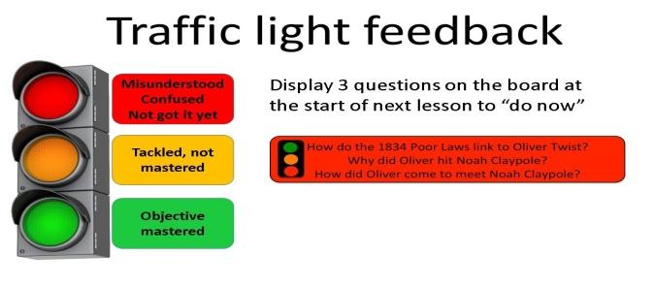 |  | Poster Success

Unit 3 Critical analysis of the role of social media and the internet on deep slow thought |  | Lesson 6
Teacher name: Zhexenbina A.A |  | School of Oriental Studies at Kazakh National University named after al-Farabi
Date: 17.10.2023
Grade: 8 Б |  | Number present: | absent:
Lesson title | Vocabulary: TV programs
Learning objectives | 8.2.1.1 understand with little or no support the main points in extended talk on a wide range of general and curricular topics  8.3.7.1 use appropriate subject-specific vocabulary and syntax to talk about a range of general topics, and some curricular topics  8.4.8.1 use familiar and some unfamiliar paper and digital reference resources to check meaning and extend understanding
Lesson objectives | Learners will be able to:  - present TV programmes  - identify items from TV/newspapers  - listen and read for specific information
Value links | Generosity – This may be a core value of yours if you cherish people who will give their time and resources to people in need. You may consider yourself to be a generous person if you find joy and meaning in giving to others.
Plan

Stages / Time | Teachers actions | Students actions | Assessment criteria | Resources
Beginning of the lesson  Warming-up  3 min  Pre-learning  «Brainstorming» method  7 min. | Organization moment :  1.Greeting.  Ask about the weather.  The teacher sets the lesson objectives, letting students know what to anticipate from the lesson.  Warming up  Where are you from?  How old are you?  What color is it?  How many students are there in class?  What day of the week today?  Revise the language of the previous lesson.  Lead – In | The aim: To develop pupils speaking skills and create friendly atmosphere  Efficiency: By wishing each other they feel better and feel the support of others  Students of the class are listed.  Students' attention is drawn to the lesson.  Determines the topic and purpose of the lesson  • Learners talk about favourite dayprevious lesson vocabulary  Students say different words from the picture and count one to hundred | The teacher to assess learners for their ability.  “Good job!  Well done!”  Formative Assessment  Good job!  Descriptor:  - talk about favourite day  Total: 1 point  Assessment criteria  - Learners have met the learning objectives if they can talk about TV programmes | Pictures  worksheet  Student’s book
Middle of the lesson  Presentation part.  30 min | Ex:1 P:34  • Ask Ss to look at the pictures.  • Play the recording. Ss listen and repeat chorally and/or individually  Ex: 2 P: 34  • Ask Ss to read out the list of items from TV & the Media and then ask Ss to talk in pairs about which of the items you can see on TV and which you can read in the newspaper as well as which of them they prefer.  • Monitor the activity around the class and then ask some pairs to report back to the class  Ex: 3 P: 35  • Elicit what, if anything, Ss know about the BBC. Then elicit questions from various Ss around the class and write two of them on the board.  • Play the recording. Ss listen and read the text and check if their questions are answered.  Ex: 4 P: 35  • Ask Ss to read the statements 1-3.  • Give Ss time to read the text and complete the task.  • Check Ss’ answers around the class.  Conclusion during the lesson some tasks differentiated by outcomes of the students and by their abilities. | Pupils listen and repeat.  ANSWERS  Student’s own answer  Pupils look at the TV and media box. Answer the question.  ANSWERS  TV – documentary, film, cartoon, international news, reality show, political discussion, weather, talent show Newspaper – international news, political discussion, comic strip, weather, horoscope  Pupils think of two questions. Answer the questions.  ANSWERS  When was it founded? (1922) What does it do? (It broadcasts on radio, TV and online and produces a wide range of programmes including dramas, sitcoms and educational documentaries.)  Pupils read the text again and mark sentences.  ANSWERS  1 T  2 F At the time, many people didn’t think that television would ever become popular!  3 F It also produces an exciting range of dramas, sitcoms and game shows as well as hundreds of educational documentaries. | Descriptor:  - listen and repeat  Total: 2 point  Self assessment  Descriptor:  - answer the question.  Total: 3 point  Descriptor:  - think of two questions  - answer the question  Total: 3 point  pupils are evaluated by collecting colour pencils  -Make CCQ questions Yes / No  Total: 10 point | Card  Worksheet  Students book
End of the lesson  5 min | FEEDBACK  Learners provide feedback on what they have learned at the lesson.  Ex:  Home task: | 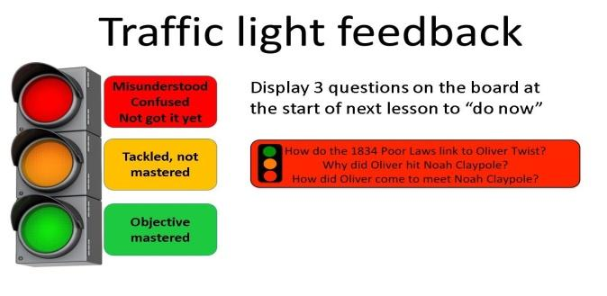 |  | Poster Success

Unit : Creating a survey on social media use and collating the results |  | Lesson 7
Teacher name: |  | School of Oriental Studies at Kazakh National University named after al-Farabi
Date: 24.10.2024
Grade: 8 Б |  | Number present: | absent:
Lesson title | Phrasal verbs (keep)
Learning objectives | 8.3.7.1 use appropriate subject-specific vocabulary and syntax to talk about a range of general topics, and some curricular topics  8.5.6.1 link independently, sentences into coherent paragraphs using a variety of basic connectors on a range of familiar general topics and some curricular topics  8.4.8.1 use familiar and some unfamiliar paper and digital reference resources to check meaning and extend understanding
Lesson objectives | Learners will be able to:  - use lexis/syntax norms in appropriate situations or context  - write a coherent paragraph/short text stating and explaining an idea/argument  - identify and understand a wider range of written information
Value links | Integrity – Integrity is the quality of having strong moral principles. So, a person with integrity will always act with honesty and adhere to their own moral code regardless of what others do.
Plan

Stages / Time | Teachers actions | Students actions | Assessment criteria | Resources
Beginning of the lesson  Warming-up  3 min  Pre-learning  «Brainstorming» method  7 min. | Organization moment :  1.Greeting.  Ask about the weather.  The teacher sets the lesson objectives, letting students know what to anticipate from the lesson.  Warming up  Where are you from?  How old are you?  What color is it?  How many students are there in class?  What day of the week today?  Revise the language of the previous lesson.  Lead – In  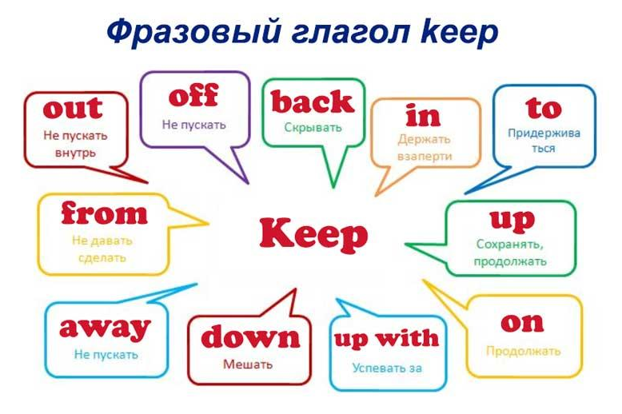 | The aim: To develop pupils speaking skills and create friendly atmosphere  Efficiency: By wishing each other they feel better and feel the support of others  Students of the class are listed.  Students' attention is drawn to the lesson.  • Learners write the numbers from previous lesson  Determines the topic and purpose of the lesson  Students say different words from the picture | The teacher to assess learners for their ability.  “Good job!  Well done!”  Formative Assessment  Good job!  Descriptor:  -know key phrases  - can make sentence  - know vocabulary of previous lesson  Total: 1 point  Assessment criteria  - Learners have met the learning objectives if they can: To talk about phrasal verbs (keep) | Pictures  worksheet  Student’s book
Middle of the lesson  Presentation part.  30 min | Ex:5 P:35  • Consolidate information in a text. Give Ss time to consider their answers to the question and then elicit answers from various Ss around the class.  Ex: 6 P: 35  • Present and practise phrasal verbs with keep  • Read out the box and explain the task.  • Give Ss time to complete the task.  • Check Ss’ answers  Ex: 7 P: 35  • listen for specific information  • Explain the task and ask Ss to read the lists.  • Play the recording. Ss listen and match the people to the programmes.  • Check Ss’ answers.  Ex: 8 P: 35  • decide on a TV programme to watch (expressing likes/dislikes)  • Explain the task and ask Ss to work in pairs and act out a dialogue using the TV guide and the useful language in the box.  • Monitor the activity around the class and then ask some pairs to act out their dialogues in front of the class.  Conclusion during the lesson some tasks differentiated by outcomes of the students and by their abilities. | Pupils answer the question  ANSWERS  I think the BBC is a symbol of national identity for the British people because everyone knows what it is, everyone watches it and it has produced so many popular programmes that have been part of people’s lives for so long.  Pupils read the box, then complete the sentences.  ANSWERS  1 away 2 on 3 up with  4 off  Pupils listen and match the people to their favourite TV programmes.  ANSWERS  1 C 2 H 3 D 4 B 5 E  Pupils work in pairs. Use the TV guide and the useful language box to decide what to watch tonight.  ANSWERS  Suggested Answer Key  A: There’s a documentary on tonight. Do you fancy watching it?  B: Not really. I’m not keen on documentaries. Is there anything else on?  A: There’s a soap opera on Channel 2.  B: I like soap operas. What time is it on?  A: 6:40.  B: OK! Let’s watch it | Descriptor:  - answer the question  Total: 2 point  Descriptor:  - read the box  - complete the sentences  Total: 3 point  Descriptor:  - listen and match  Total: 2 point  pupils are evaluated by collecting fish  Descriptor:  - work in pairs  - use the TV guide  - decide what to watch tonight  Total: 2 point  -Make CCQ questions Yes / No | Card  Worksheet  Students book
End of the lesson  5 min | FEEDBACK  Learners provide feedback on what they have learned at the lesson.  Ex:  Home task: | 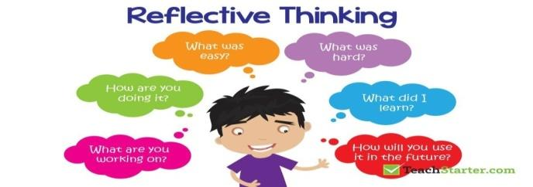 |  | Poster Success

Unit: Writing: A letter to the editor suggesting solutions to a problem. Summative assessment for the unit 1 |  | Lesson 8
Teacher name: Zhexenbina A.A |  | School of Oriental Studies at Kazakh National University named after al-Farabi
Date: 14.11.2023
Grade: 8 Б |  | Number present: | absent:
Lesson title | Everyday English: Expressing opinions
Learning objectives | 8.2.1.1 understand with little or no support the main points in extended talk on a wide range of general and curricular topics  8.4.6.1 recognise the attitude or opinion of the writer on a growing range of unfamiliar general and curricular topics, including some extended texts  8.6.14.1 use some prepositions before nouns and adjectives use prepositions as, like to indicate manner use dependent prepositions following adjectives on a range of familiar general and curricular topics
Lesson objectives | Learners will be able to:  -jot down some key words and phrases  - identify and interpret the author’s tone/opinion at basic level
Value links | Perseverance – People who value perseverance will work through adversity and be determined to get a result. This is a great treat for employees and entrepreneurs alike.
Plan

Stages / Time | Teachers actions | Students actions | Assessment criteria | Resources
Beginning of the lesson  Warming-up  3 min  Pre-learning  «Brainstorming» method  7 min. | Organization moment :  1.Greeting.  Ask about the weather.  The teacher sets the lesson objectives, letting students know what to anticipate from the lesson.  Warming up  Hot Potato  Students stand in a circle and pass an object around. When the timer goes off, or the music stops, the student holding the hot potato has to do something.  Lead – In  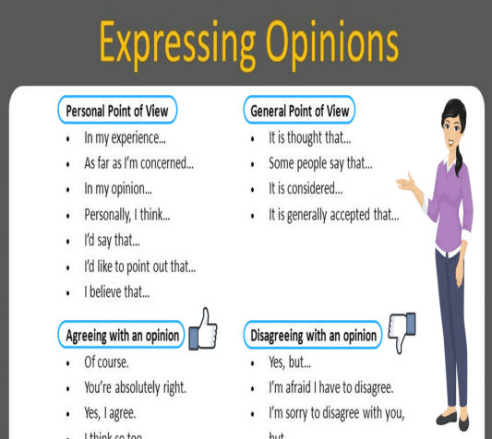 | The aim: To develop pupils speaking skills and create friendly atmosphere  Efficiency: By wishing each other they feel better and feel the support of others  Students of the class are listed.  Students' attention is drawn to the lesson.  • Learners talk about favourite day previous lesson vocabulary  Determines the topic and purpose of the lesson  Students say different words from the picture | The teacher to assess learners for their ability.  “Good job!  Well done!”  Formative Assessment  Good job!  Descriptor:  -know key phrases  - can make sentence  - know vocabulary of previous lesson  Total: 1 point  Assessment criteria  - Learners have met the learning objectives if they can talk about opinions | Pictures  worksheet  Student’s book
Middle of the lesson  Presentation part.  30 min | Ex:1 P:36  • Practise pronunciation of situational language; to identify phrases which express/ask for opinions  • Play the recording. Ss listen and repeat chorally and/or individually.,  • Pay attention to Ss’ pronunciation and intonation and correct as necessary.  • Then elicit which of the items ask for an opinion or express a positive/negative opinion and ask Ss to mark them accordingly.  • Check Ss’ answers.  Ex: 2 P: 36  • Listen and read for specific information  • Read out the questions.  • Play the recording. Ss listen and read the text to find out the answers.  Ex: 3 P: 36  • Learn synonymous phrases Read out the phrases. Refer Ss back to the dialogue and elicit the synonymous ones from various Ss around the class  Ex: 4 P: 36  • Practise role-playing  • Explain the situation and ask Ss to work in pairs and act out a dialogue.  • Remind Ss that they can use the dialogue in Ex. 2 as a model as well as any ideas of their own to complete the task.  • Ss complete the task in pairs. To help Ss, draw the following diagram on the board and elicit appropriate phrases Ss should use. Write them on the board. Ss can refer to the diagram while doing the task.  Conclusion during the lesson some tasks differentiated by outcomes of the students and by their abilities. | Pupils listen and repeat. Write the correct letter.  ANSWERS  What was it like? A  It was fantastic! B  The dancers were amazing! B  Did you enjoy it? A  Not really. C  It was nothing special. C  Pupils listen and read the dialogue to find out.  ANSWERS  Jane was at the ballet. Aidar watched a film with his brother at home. Jane enjoyed the ballet. Aidar didn’t enjoy the film.  Pupils find sentences in the dialogue which mean  ANSWERS  Of course! = Sure!  What did you think of it? = What was it like?  Did you have a good time? = Did you enjoy it? It wasn’t great. = It was nothing special  Pupils use the sentences in ex 1 and the dialogue in ex 2 to write or act out your dialogue  ANSWERS  A: Hi, Mary. It’s Nuro. I tried calling you on Saturday night, but you didn’t answer your phone.  B: Oh, hi Nuro! Yes, sorry! I was at the theatre.  A: Really? What was it like?  B: It was fantastic! The show was amazing! What did you do on Saturday? | Descriptor:  - listen and repeat  - write the correct letter  Total: 2 point  Descriptor:  - listen and read the dialogue  Total: 3 point  Descriptor:  - find sentences in the dialogue  Total: 3 point  pupils are evaluated by collecting colour pencils  Descriptor:  - use the sentences  - write or act out your dialogue  -Make CCQ questions Yes / No  Total: 10 point | Card  Worksheet  Students book
End of the lesson  5 min | FEEDBACK  Learners provide feedback on what they have learned at the lesson.  Ex:  Home task: |  |  | Poster Success

Unit: Vocabulary: Daily routines and Free – time activities |  | Lesson 9
Teacher name: Zhexenbina A.A |  | School of Oriental Studies at Kazakh National University named after al-Farabi
Date: 21.11.2023
Grade: 8 Б |  | Number present: | absent:
Lesson title | Across cultures: Festivals around the world
Learning objectives | 8.1.10.1 use talk or writing as a means of reflecting on and exploring a range of perspectives on the world  8.3.7.1 use appropriate subject-specific vocabulary and syntax to talk about a range of general topics, and some curricular topics  8.4.1.1 understand the main points in texts on a growing range of unfamiliar general and curricular topics, including some extended texts
Lesson objectives | Learners will be able to:y  - demonstrate reflection and deep thinking on acquired information/knowledge  - explain the topical word by giving definition/synonym  -- identify the central idea, the intended audience and the author’s purpose
Value links | Self-Discipline – If you value self-discipline, you might be a person who wakes up early, exercises daily, and doesn’t get distracted by vices.
Plan

Stages / Time | Teachers actions | Students actions | Assessment criteria | Resources
Beginning of the lesson  Warming-up  3 min  Pre-learning  «Brainstorming» method  7 min. | Organization moment :  1.Greeting.  Ask about the weather.  The teacher sets the lesson objectives, letting students know what to anticipate from the lesson.  Warming up  Hot Potato  Students stand in a circle and pass an object around. When the timer goes off, or the music stops, the student holding the hot potato has to do something.  Write some of the words from the previous lesson  Lead – In  Where does celebrate this festival? | “The wish lamp” method helps to start the lesson with good wishes to each other.  The aim: To develop pupils speaking skills and create friendly atmosphere  Efficiency: By wishing each other they feel better and feel the support of others  Students of the class are listed.  Students' attention is drawn to the lesson.  • Learners talk about rooms previous lesson vocabulary  Determines the topic and purpose of the lesson  Students say different words from the picture | The teacher to assess learners for their ability.  “Good job!  Well done!”  Formative Assessment  Good job!  Descriptor:  -know key phrases  - can make sentence  - know vocabulary of previous lesson  Total: 1 point  Assessment criteria  - Learners have met the learning objectives if they can: Talk about celebration in your country | Pictures  worksheet  Student’s book
Middle of the lesson  Presentation part.  30 min | Ex:1 P:37  • Introduce the topic; to listen and read for specific information  • Direct Ss’ attention to the pictures and elicit what festivals they show and what, if anything, they know about them.  • Play the recording. Ss listen and follow the text in their books to find out.  Ex: 2 P: 37  • Read for specific information  • Read the questions aloud one at a time and ask Ss to read the texts again and answer them.  • Check Ss’ answers.  Ex: 3 P: 37  • Complete a table and present two festivals  • Ask Ss to copy the table into their notebooks.  • Give Ss time to read the texts again and then complete the table. • Ask various Ss to use the table to present the festivals to the class.  Ex: 4 P: 37  • Write a short text about a cultural festival  • Explain the task and ask Ss to work in small groups and collect information from the Internet about a cultural festival in their country and make notes.  • Then ask Ss to use their notes to write a short text. Ask various Ss to read their text to the class.  • Alternatively, assign the task as HW and check Ss' answers in the next lesson.  Conclusion during the lesson some tasks differentiated by outcomes of the students and by their abilities. | • Pupils look at the pictures. Answer the question  ANSWERS  The festivals are Shakespeare’s Birthday and the Festival of Nomadic Civilisation.  • Pupils read the text again and answer the question.  ANSWERS  1 He was born in Stratford-upon-Avon.  2 He/She carries ‘the quill’.  3 The mayor puts flowers on Shakespeare’s grave.  4 It is held in Astana.  5 They can try food and traditional crafts and attend music and dance performances  • Pupils complete the table in your notebook.  ANSWERS  Students own answer.  • Pupils use your notes to write a short text.  ANSWERS  The Navroz Festival takes place on 22nd March in towns and cities across the country. There are polo matches, folk dancing and music performances. It is a celebration of the new year and people cook and eat lamb. | Descriptor:  - look at the pictures.  - answer the question  Total: 2 point  Self Assessment  Descriptor:  - read the text again and answer the question.  Total: 2 point  Descriptor:  - complete the table in your notebook  Total: 2 point  pupils are evaluated by collecting places where they live  Descriptor:  - use your notes to write a short text  Total: 2 point  -Make CCQ questions Yes / No  Total: 10 point | Card  Worksheet  Students book
End of the lesson  5 min | FEEDBACK  Learners provide feedback on what they have learned at the lesson.  Ex:  Home task: |  |  | Poster Success

Unit: Reading: Being 16 |  | Lesson 10
Teacher name: Zhexenbina A.A |  | School of Oriental Studies at Kazakh National University named after al-Farabi
Date: 28.11.2023
Grade: 8 Б |  | Number present: | absent:
Lesson title | Across curriculum: Sound and hearing
Learning objectives | 8.3.7.1 use appropriate subject-specific vocabulary and syntax to talk about a range of general topics, and some curricular topics  8.2.2.1 understand with little or no support most specific information in extended talk on a wide range of general and curricular topics  8.5.2.1 write with minimal support about real and imaginary past events, activities and experiences on a growing range of familiar general topics and some curricular topics
Lesson objectives | Learners will be able to:  - use lexis/syntax norms in appropriate situations or context  -identify specific information in a variety of situations and contexts  - support an argument with the relevant evidence
Value links | Humility – You might highly value humility if you find yourself disgusted by people who are arrogant or braggadocious, and instead find yourself gravitating to people who are always expressing their gratefulness for the blessings in their life.
Plan

Stages / Time | Teachers actions | Students actions | Assessment criteria | Resources
Beginning of the lesson  Warming-up  3 min  Pre-learning  «Brainstorming» method  7 min. | Organization moment :  1.Greeting.  Ask about the weather.  The teacher sets the lesson objectives, letting students know what to anticipate from the lesson.  Warming up  The Categories Game (Stop The Bus!)  This one is a great activity to get students engaged before class begins. The teacher will say a letter of the alphabet, and the students have to think of things that start with that letter.  Ask the rest of the class to guess which place it is. Demonstrate this yourself first  Lead – In  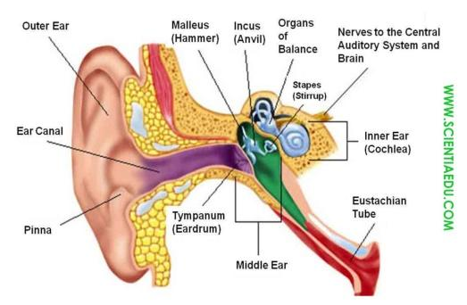 | The aim: To develop pupils speaking skills and create friendly atmosphere  Efficiency: By wishing each other they feel better and feel the support of others  Students of the class are listed.  Students' attention is drawn to the lesson.  Learners find mime an action associated with one of the places  Determines the topic and purpose of the lesson  Students say different words from the picture | The teacher to assess learners for their ability.  “Good job!  Well done!”  Formative Assessment  Good job!  Descriptor:  -know key phrases  - can make sentence  - know vocabulary of previous lesson  Total: 1 point  Assessment criteria  - Learners have met the learning objectives if they can: Talk about literature | Pictures  worksheet  Student’s book
Middle of the lesson  Presentation part.  30 min | Ex:1 P:38  • Introduce the topic and listen and read for specific information • Ask Ss to read the statements 1-4. Elicit Ss’ guesses as to which one is incorrect.  • Play the recording. Ss listen and read the text to check if their guesses were correct.  Ex: 2 P: 38  • Read for order  • Ask Ss to read statements 1-5.  • Give Ss time to read the text again and complete the task.  • Check Ss’ answers around the class.  Ex: 3 P: 38  • consolidate comprehension of a text  • Give Ss time to read the text again and label the diagram writing their answers in the notebook.  • Check Ss’ answers.  Ex: 4 P: 38  • Prepare a monologue; to consolidate information from a text  • Ask Ss to use the diagram to prepare a monologue.  • Then ask various Ss to give their monologue to the class about how we hear.  • Record the monologues. | • Pupils read the following statements about sound.  ANSWERS  4 is incorrect  • Pupils read the text and put the sentences in the correct order  ANSWERS  3, 5, 1, 2, 4  • Pupils use words from the text to label the diagram  ANSWERS  1 eardrum  2 stirrup  3 cochlea  • Pupils look at the diagram above and tell the class how we hear.  ANSWERS  Sound travels in waves and these are collected in the outer ear. Then they go through the ear canal and hit the eardrum which vibrates. This moves some little bones in our ears called the hammer, the anvil and the stirrup which bump against each other and move the sound along into the cochlea. This is a curved tube that looks like a snail shell. The sound waves move to the nerves here that create signals to tell the brain what we can hear. | Descriptor:  - read the following statements  Total: 2 point  Descriptor:  - read the text  - put the sentences in the correct order  Total: 2 point  Descriptor:  - use words from the text  - label the diagram  Total: 2 point  Descriptor:  - look at the diagram  - tell the class how we hear  Total: 2 point  pupils are evaluated by collecting colour pencils  -Make CCQ questions Yes / No | Card  Worksheet  Students book
End of the lesson  5 min | FEEDBACK  Learners provide feedback on what they have learned at the lesson.  Ex:  Home task: |  |  | Poster Success

Unit Vocabulary: Leisure activities and chores |  | Lesson 11
Teacher name: Zhexenbina A.A |  | School of Oriental Studies at Kazakh National University named after al-Farabi
Date: 05.12.2023
Grade:8 Б |  | Number present: | absent:
Lesson title | Writing: An email reviewing a concert  Summative Assessment for the unit 3
Learning objectives | 8.5.1.1 plan, write, edit and proofread work at text level with little support on a range of general and curricular topics  8.2.2.1 understand with little or no support most specific information in extended talk on a wide range of general and curricular topics
Lesson objectives | Learners will be able to:  - check their own and others’ writing to ensure that it communicates what they intended and improve the writing if needed  - respond adequately to personal questions in a variety of situations and contexts (e.g. in interviews and dialogues)
Value links | Kindness – If you value kindness, you’ll likely always be respectful of people around you, be gentle with criticism, and always willing to welcome people with open arms.
Plan

Stages / Time | Teachers actions | Students actions | Assessment criteria | Resources
Beginning of the lesson  Warming-up  3 min  Pre-learning  «Brainstorming» method  7 min. | Organization moment :  1.Greeting.  Ask about the weather.  The teacher sets the lesson objectives, letting students know what to anticipate from the lesson.  Warming up  The Categories Game (Stop The Bus!)  This one is a great activity to get students engaged before class begins. The teacher will say a letter of the alphabet, and the students have to think of things that start with that letter.  Revise the language of the previous lesson  Lead – In  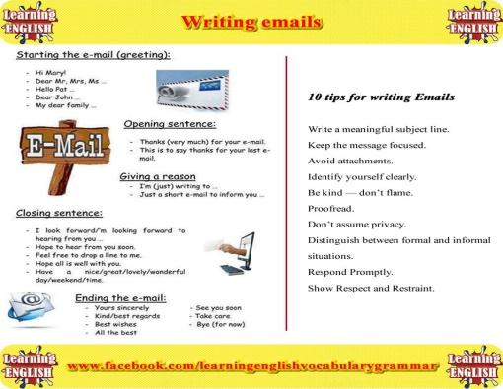 | The aim: To develop pupils speaking skills and create friendly atmosphere  Efficiency: By wishing each other they feel better and feel the support of others  Students of the class are listed.  Students' attention is drawn to the lesson.  Learners find mime an action associated with one of the places  Determines the topic and purpose of the lesson  Students say different words from the picture | The teacher to assess learners for their ability.  “Good job!  Well done!”  Formative Assessment  Good job!  Assessment criteria  - Learners have met the learning objectives if they can: Talk about reviewing a concert  Descriptor:  -know key phrases  - know vocabulary of previous lesson  Total: 1 point | Pictures  worksheet  Student’s book
Middle of the lesson  Presentation part.  30 min | Ex:1 P:39  • Read for specific information Ask Ss to read the email and then elicit answers to the questions.  Ex: 2 P: 39  • Read for cohesion and coherence • Explain the task and ask Ss to read the email again. Give Ss time to complete the task.  • Check Ss' answers.  Ex: 4 P: 39  • Substitute adjectives  • Ask Ss to read the paragraph and then to substitute the adjectives 1-4 for suitable alternatives from the list.  • Check Ss' answers  Summative assessment for the unit « Entertainment and media»  Conclusion during the lesson some tasks differentiated by outcomes of the students and by their abilities. | Pupils look at the email. Answer the question.  ANSWERS  Nazira is writing it. Nazira and Rustam went to an Ed Sheeran concert.  Pupils read the email again and choose the correct words.  ANSWERS  1 amazing  2 interesting  3 excited  4 boring  5 exhausted  Pupils replace the adjectives in the sentences .  ANSWERS  1 excellent  2 talented  3 lively  4 catchy | Descriptor:  - look at the email  - answer the question  Total: 2 point  pupils are evaluated by collecting fish  Descriptor:  - read the email  - choose the correct words  Total: 2 point  Descriptor:  - replace the adjectives  Total: 2point  -Make CCQ questions Yes / No | Card  Worksheet  Students book
End of the lesson  5 min | FEEDBACK  Learners provide feedback on what they have learned at the lesson.  Ex:  Home task: |  |  | Poster Success

Unit: Use of English: Present simple, Present continuous, Present perfect |  | Lesson 12
Teacher name: Zhexenbina A.A |  | School of Oriental Studies at Kazakh National University named after al-Farabi
Date: 12.12.2023
Место для ввода текста.Grade: 8 Б |  | Number present: | absent:
Lesson title | Vocabulary: Physical activities
Learning objectives | 8.3.7.1 use appropriate subject-specific vocabulary and syntax to talk about a range of general topics, and some curricular topics  8.2.2.1 understand with little or no support most specific information in extended talk on a wide range of general and curricular topics
Lesson objectives | Learners will be able to:  - use lexis/syntax norms in appropriate situations or context  - respond adequately to personal questions in a variety of situations and contexts (e.g. in interviews and dialogues)
Value links | Gratitude – You value gratitude if you find yourself respecting people who say please and thank you. If you’re a religious person who values gratitude, you may always insist on praying before eating your dinner.
Plan

Stages / Time | Teachers actions | Students actions | Assessment criteria | Resources
Beginning of the lesson  Warming-up  3 min  Pre-learning  «Brainstorming» method  7 min. | Organization moment :  1.Greeting.  Ask about the weather.  The teacher sets the lesson objectives, letting students know what to anticipate from the lesson.  Warming up  Hot Potato  Students stand in a circle and pass an object around. When the timer goes off, or the music stops, the student holding the hot potato has to do something.  Ask the pupils questions about their sports.  Lead – In | The aim: To develop pupils speaking skills and create friendly atmosphere  Efficiency: By wishing each other they feel better and feel the support of others  Students of the class are listed.  Students' attention is drawn to the lesson.  Learners answer the question  Determines the topic and purpose of the lesson  Students say different words from the picture  What do you see in this picture?  What are they doing? | The teacher to assess learners for their ability.  “Good job!  Well done!”  Formative Assessment  Good job!  Assessment criteria  - To revise school rules; to write about classroom rules; to develop the pupils’ listening skills  Descriptor:  -can speak fluently on theme  Total: 2point | Pictures  worksheet  Student’s book
Middle of the lesson  Presentation part.  30 min | Ex:1 P:41  • Present physical activities  • Ask Ss to look at the pictures.  • Play the recording with pauses for Ss to repeat chorally and/or individually.  Ex: 2 P: 41  • Discuss activities and express an opinion  • Ask Ss to discuss the questions in pairs.  • Monitor the activity around the class and then ask various Ss to tell the class  Ex: 3 P: 41  • Classify activities as group/individual activities  • Ask Ss to decide in pairs which of the activities in the pictures are group activities and which are individual activities.  • Elicit answers from Ss around the class.  Conclusion during the lesson some tasks differentiated by outcomes of the students and by their abilities. | Pupils look at the pictures. Listen and repeat.  ANSWERS  Student’s own answer  Pupils answer the question. Which of these activities do you like doing? Which would you like to try? Why?  ANSWERS  I like swimming. I would like to try aerial yoga and Zumba.  I think they would be fun.  Pupils answer the question. Which of the above are group activities? Which are individual activities?  ANSWERS  Group: Pilates, Zumba, rugby,  Individual: aerial yoga, aikido, weightlifting, squash, boxing, swimming | Descriptor:  - look at the pictures  - listen and repeat.  Total: 1 point  pupils are evaluated by collecting fish  Descriptor:  - answer the question.  Total: 1 point  -Make CCQ questions Yes / No | Card  Worksheet  Students book
End of the lesson  5 min | FEEDBACK  Learners provide feedback on what they have learned at the lesson.  Ex:  Home task: |  |  | Poster Success

Unit: Use of English: Present perfect continuous |  | Lesson 13
.Teacher name: Zhexenbina A.A |  | School of Oriental Studies at Kazakh National University named after al-Farabi
Date: 19.12.2023
Grade: 8 Б |  | Number present: | absent:
Lesson title | Reading: Jane’s sports blog
Learning objectives | 8.3.7.1 use appropriate subject-specific vocabulary and syntax to talk about a range of general topics, and some curricular topics  8.4.2.1 understand specific information and detail in texts on a growing range of familiar general and curricular topics, including some extended texts  8.2.1.1 understand with little or no support the main points in extended talk on a wide range of general and curricular topics
Lesson objectives | Learners will be able to:  - formulate a simple summary or character outline  - respond adequately to personal questions in a variety of situations and contexts (e.g. in interviews and dialogues)
Value links | Patience – A person who has patience as a core personal value is going to prioritize giving their time to others. They will sit down and be calm while waiting for others. This is a great trait for a teacher.
Plan

Stages / Time | Teachers actions | Students actions | Assessment criteria | Resources
Beginning of the lesson  Warming-up  3 min  Pre-learning  «Brainstorming» method  7 min. | Organization moment :  1.Greeting.  Ask about the weather.  The teacher sets the lesson objectives, letting students know what to anticipate from the lesson.  Warming up  Hot Potato  Students stand in a circle and pass an object around. When the timer goes off, or the music stops, the student holding the hot potato has to do something.  Revise the vocabulary of the previous lesson  Lead – In | .  The aim: To develop pupils speaking skills and create friendly atmosphere  Efficiency: By wishing each other they feel better and feel the support of others  Students of the class are listed.  Students' attention is drawn to the lesson.  Determines the topic and purpose of the lesson  Students say different words from the picture  How to play this sport? | The teacher to assess learners for their ability.  “Good job!  Well done!”  Formative Assessment  Good job!  Assessment criteria  - Learners have met the learning objectives if they can: explore other subject areas talk about Jane’s sports blog | Pictures  worksheet  Student’s book
Middle of the lesson  Presentation part.  30 min | Ex:1 P:42  • Introduce the topic; to listen and read for gist  • Ask Ss to look at the picture. Elicit what if anything Ss know about Quidditch and Harry Potter.  • Play the recording. Ss listen and read the text to find out.  • Elicit answers from Ss around the class.  Ex: 2 P: 42  • Read for specific information  • Read out the Study Skills box and tell Ss that this tip will help them to complete the task successfully.  • Give Ss time to read the texts again and read the sentences and then match them to the sports.  • Check Ss’ answers.  Ex: 3 P: 42  • Read for specific information  • Explain the task.  • Allow Ss time to read the questions and answer them referring to the text as necessary.  • Check Ss’ answers.  Conclusion during the lesson some tasks differentiated by outcomes of the students and by their abilities. | Pupils look at the picture. Answer the question.  ANSWERS  Quidditch is a fictional sport from the books about a young wizard called Harry Potter by JK Rowling. It is his favourite sport.  Pupils read the text again and match the sports to the sentences  ANSWERS  1 Q 3 Q 5 Q 2 ST 4 ST 6 ST  Pupils answer the questions. Use ideas from the texts as well as your own.  ANSWERS  Suggested Answer Key 1 In the Harry Potter books, the players fly around on broomsticks but in real life they run around a pitch with the broomsticks between their legs.  2 A Quidditch player must be good at teamwork.  3 Sepak Takraw is similar to volleyball.  4 It’s really fast and athletic and good for people who are good at football. | Descriptor:  - look at the jobs  - answer the question.  Total: 2 point  Self assessment  Descriptor:  - read the text  - match the sports to the sentences  Total: 3 point  Descriptor:  - answer the questions  - use ideas from the texts  Total: 3 point  pupils are evaluated by collecting places  -Make CCQ questions Yes / No  Total: 10 point | Card  Worksheet  Students book
End of the lesson  5 min | FEEDBACK  Learners provide feedback on what they have learned at the lesson.  Ex:  Home task: |  |  | Poster Success

Unit Vocabulary: clothing and shoes |  | Lesson 14
Teacher name: Zhexenbina A.A |  | School of Oriental Studies at Kazakh National University named after al-Farabi
Date: 26.12.2023
Grade: 8 Б |  | Number present: | absent:
Lesson title | Sport, health and exercise
Learning objectives | 8.5.3.1 write with moderate grammatical accuracy on a growing range of familiar general and curricular topics  8.2.2.1 understand with little or no support most specific information in extended talk on a wide range of general and curricular topics
Lesson objectives | Learners will be able to:  - use most of the preintermediate level grammar correctly  - respond adequately to personal questions in a variety of situations and contexts (e.g. in interviews and dialogues)
Value links | Open-Mindedness – An open-minded person is someone who is always willing to hear new points of view and even change their own point of view if new arguments are highly convincing. It’s the opposite of stubbornness.
Plan

Stages / Time | Teachers actions | Students actions | Assessment criteria | Resources
Beginning of the lesson  Warming-up  3 min  Pre-learning  «Brainstorming» method  7 min. | Organization moment :  1.Greeting.  Ask about the weather.  The teacher sets the lesson objectives, letting students know what to anticipate from the lesson.  Warming up  Hot Potato  Students stand in a circle and pass an object around. When the timer goes off, or the music stops, the student holding the hot potato has to do something.  Lead – In  Ask pupils to present their posters from the previous lesson. | “The wish lamp” method helps to start the lesson with good wishes to each other.  The aim: To develop pupils speaking skills and create friendly atmosphere  Efficiency: By wishing each other they feel better and feel the support of others  Students of the class are listed.  Students' attention is drawn to the lesson.  Students analyze the given pictures in pairs.  Determines the topic and purpose of the lesson  Students say different words from the picture | The teacher to assess learners for their ability.  “Good job!  Well done!”  Formative Assessment  Good job!  Assessment criteria  Identify the main points of short texts using contextual clues on familiar topics | Pictures  worksheet  Student’s book
Middle of the lesson  Presentation part.  30 min | Ex: 4 P: 43  • Consolidate new vocabulary  • Direct Ss to the words in bold in the texts and then give them time to match them to the synonymous words/phrases in the list.  • Check Ss’ answers.  Ex: 5 P: 43  • Express an opinion  • Ask Ss to discuss the questions in pairs.  • Monitor the activity around the class and then ask various Ss to tell the class.  Ex: 6 P: 43  • Form compound nouns  • Explain the task and give Ss time to complete it.  • Check Ss’ answers and then give Ss time to make sentences using them and elicit sentences from Ss around the class.  Ex: 7 P: 43  • Present and practise verbs related to sports  • Read through the list of verbs and give Ss time to complete the sentences using their dictionaries to check.  • Check Ss’ answers.  Conclusion during the lesson some tasks differentiated by outcomes of the students and by their abilities. | Pupils match the words in bold to their synonyms.  ANSWERS  joined up = became a member talented = gifted strange = weird popular = well-liked by many people fast = quick  Pupils answer the question.  ANSWERS  I want to try Sepak Takraw because it’s athletic  Pupils match the words to form compound nouns. Make sentences using them  ANSWERS  1 c 2 a 3 d 4 b  1 Quidditch requires a lot of teamwork.  2 Serena Williams is my favourite sportsperson.  3 Sepak Takraw is similar to volleyball.  4 In Quidditch players use broomsticks  Pupils complete the sentences.  ANSWERS  1 pass  2 beat  3 kick  4 score  5 hit  6 catch | Descriptor:  - match the words in bold to their synonyms  Total: 3 point  Descriptor:  - answer the question.  Total: 4 point  Descriptor:  - match the words to form compound nouns  Total: 3 point  Descriptor:  - complete the sentences  Total: 3 point | Card  Worksheet  Students book
End of the lesson  5 min | FEEDBACK  Learners provide feedback on what they have learned at the lesson.  Ex:  Home task: |  |  | Poster Success

Unit: Entertainment & the Media |  | Lesson 15
Teacher name: Zhexenbina A.A |  | School of Oriental Studies at Kazakh National University named after al-Farabi
Date: 09.01.2024
Grade: 8 Б |  | Number present: | absent:
Lesson title | Use of English: will / to be going to
Learning objectives | 8.3.7.1 use appropriate subject-specific vocabulary and syntax to talk about a range of general topics, and some curricular topics  8.2.2.1 understand with little or no support most specific information in extended talk on a wide range of general and curricular topics  8.4.6.1 recognise the attitude or opinion of the writer on a growing range of unfamiliar general and curricular topics, including some extended texts
Lesson objectives | Learners will be able to:  - respond adequately to personal questions in a variety of situations and contexts (e.g. in interviews and dialogues)  - identify and interpret the author’s tone/opinion at basic level
Value links | Open-Mindedness – An open-minded person is someone who is always willing to hear new points of view and even change their own point of view if new arguments are highly convincing. It’s the opposite of stubbornness.
Plan

Stages / Time | Teachers actions | Students actions | Assessment criteria | Resources
Beginning of the lesson  Warming-up  3 min  Pre-learning  «Brainstorming» method  7 min. | Organization moment :  1.Greeting.  Ask about the weather.  The teacher sets the lesson objectives, letting students know what to anticipate from the lesson.  Warming up  Hot Potato  Students stand in a circle and pass an object around. When the timer goes off, or the music stops, the student holding the hot potato has to do something.  Lead – In  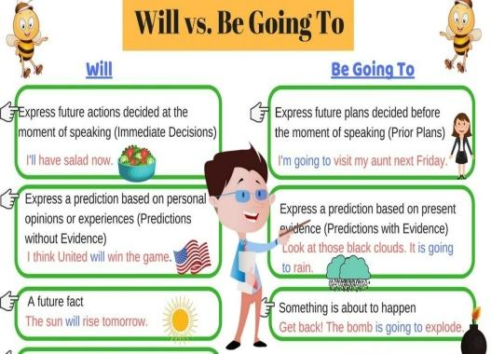 | The aim: To develop pupils speaking skills and create friendly atmosphere  Efficiency: By wishing each other they feel better and feel the support of others  Students of the class are listed.  Students' attention is drawn to the lesson.  Determines the topic and purpose of the lesson  Students say different words from the picture | The teacher to assess learners for their ability.  “Good job!  Well done!”  Formative Assessment  Good job!  Assessment criteria  - Learners have met the learning objectives if they can: Talk about plans | Pictures  worksheet  Student’s book
Middle of the lesson  Presentation part.  30 min | Ex:1 P:44  • Present will/be going to  • Present the future simple (will). Say then write on the board: I’m thirsty. I will drink some water. and Next week he will buy a new laptop. Underline I will drink and he will buy and explain that these verbs are in the future simple. Explain that we use will + the base form of the main verb to form the affirmative. Explain that we use this tense to talk about on-thespot decisions and predictions based on what we think.  • Explain the task and ask Ss to match the sentences to what they express and then check Ss' answers.  Ex: 2 P: 44  • Practise will/be going to  • Explain the task and give Ss time to complete it.  • Check Ss’ answers.  Ex: 3 P: 44  • Practise will/be going to  • Ask Ss to read the decisions 1-6 and ask and answer in pairs using will/be going to and following the example.  • Monitor the activity around the class and then ask some pairs to ask and answers in front of the rest of the class.  Ex: 4 P: 44  • Elicit when we use the present continuous with a future meaning. (We use the present continuous for fixed future arrangements.)  • Elicit examples from Ss around the class. (I’m playing football after school. I’m staying in tonight.)  Conclusion during the lesson some tasks differentiated by outcomes of the students and by their abilities. | Pupils match the sentences to what they express  ANSWERS  Student’s own answer  Pupils complete with will or be going to and the verbs in brackets.  ANSWERS  1 is going to kick  2 will become  3 is going to play  4 will gain  5 will win  6 are going to lose  7 am going to go  8 will be  9 is going to score  10 am going to watch  11 is going to enter  12 will come  Pupils Daniya has decided to live a healthy life. In pairs, ask and answer as in the example.  ANSWERS  A: Do you think she will eat a balanced diet?  B: Yes, I think she will. Is she going to eat junk food every two weeks? A: No, she isn’t. Is she going to exercise regularly?  B: Yes, she is. Do you think she will drink fizzy drinks?  A: No, she won’t. Is she going to drink eight glasses of water a day? B: Yes, she is.  Pupils answer the question. Give reasons  ANSWERS  1 a fixed arrangement in the near future  2 an action happening now  3 a fixed arrangement in the near future  4 an action happening now  5 a fixed arrangement in the near future | Descriptor:  - match the sentences  Total: 3 point  pupils are evaluated by collecting vitamins  Descriptor:  - complete with will or be going to  Total: 3 point  Descriptor:  - work in pairs  - ask and answer as in the example.  Total: 3 point  Descriptor:  - answer the question  - Give reasons  Total: 3 point  -Make CCQ questions Yes / No  Total: 10 point | Card  Worksheet  Students book
End of the lesson  5 min | FEEDBACK  Learners provide feedback on what they have learned at the lesson.  Ex:  Home task: |  |  | Poster Success

Unit: Expressing opinions |  | Lesson 16
Teacher name: Zhexenbina A.A |  | School of Oriental Studies at Kazakh National University named after al-Farabi
Date: 16.01.2024
Grade: 8 Б |  | Number present: | absent:
Lesson title | Use of English: conditionals
Learning objectives | 8.1.1.1 use speaking and listening skills to solve problems creatively and cooperatively in groups  8.2.1.1 understand with little or no support the main points in extended talk on a wide range of general and curricular topics  8.3.7.1 use appropriate subject-specific vocabulary and syntax to talk about a range of general topics, and some curricular topics
Lesson objectives | Learners will be able to:  - respond adequately to personal questions in a variety of situations and contexts (e.g. in interviews and dialogues)  - identify and interpret the author’s tone/opinion at basic level
Value links | Open-Mindedness – An open-minded person is someone who is always willing to hear new points of view and even change their own point of view if new arguments are highly convincing. It’s the opposite of stubbornness.
Plan

Stages / Time | Teachers actions | Students actions | Assessment criteria | Resources
Beginning of the lesson  Warming-up  3 min  Pre-learning  «Brainstorming» method  7 min. | Organization moment :  1.Greeting.  Ask about the weather.  The teacher sets the lesson objectives, letting students know what to anticipate from the lesson.  Warming up  Hot Potato  Students stand in a circle and pass an object around. When the timer goes off, or the music stops, the student holding the hot potato has to do something.  Lead – In | The aim: To develop pupils speaking skills and create friendly atmosphere  Efficiency: By wishing each other they feel better and feel the support of others  Students of the class are listed.  Students' attention is drawn to the lesson.  Determines the topic and purpose of the lesson  Students say different words from the picture | The teacher to assess learners for their ability.  “Good job!  Well done!”  Formative Assessment  Good job!  Assessment criteria  - Learners have met the learning objectives if they can: Talk about plans | Pictures  worksheet  Student’s book
Middle of the lesson  Presentation part.  30 min | Ex:1 P:44  • Present will/be going to  • Present the future simple (will). Say then write on the board: I’m thirsty. I will drink some water. and Next week he will buy a new laptop. Underline I will drink and he will buy and explain that these verbs are in the future simple. Explain that we use will + the base form of the main verb to form the affirmative. Explain that we use this tense to talk about on-thespot decisions and predictions based on what we think.  • Explain the task and ask Ss to match the sentences to what they express and then check Ss' answers.  Ex: 2 P: 44  • Practise will/be going to  • Explain the task and give Ss time to complete it.  • Check Ss’ answers.  Ex: 3 P: 44  • Practise will/be going to  • Ask Ss to read the decisions 1-6 and ask and answer in pairs using will/be going to and following the example.  • Monitor the activity around the class and then ask some pairs to ask and answers in front of the rest of the class.  Ex: 4 P: 44  • Elicit when we use the present continuous with a future meaning. (We use the present continuous for fixed future arrangements.)  • Elicit examples from Ss around the class. (I’m playing football after school. I’m staying in tonight.)  Conclusion during the lesson some tasks differentiated by outcomes of the students and by their abilities. | Pupils match the sentences to what they express  ANSWERS  Student’s own answer  Pupils complete with will or be going to and the verbs in brackets.  ANSWERS  1 is going to kick  2 will become  3 is going to play  4 will gain  5 will win  6 are going to lose  7 am going to go  8 will be  9 is going to score  10 am going to watch  11 is going to enter  12 will come  Pupils Daniya has decided to live a healthy life. In pairs, ask and answer as in the example.  ANSWERS  A: Do you think she will eat a balanced diet?  B: Yes, I think she will. Is she going to eat junk food every two weeks? A: No, she isn’t. Is she going to exercise regularly?  B: Yes, she is. Do you think she will drink fizzy drinks?  A: No, she won’t. Is she going to drink eight glasses of water a day? B: Yes, she is.  Pupils answer the question. Give reasons  ANSWERS  1 a fixed arrangement in the near future  2 an action happening now  3 a fixed arrangement in the near future  4 an action happening now  5 a fixed arrangement in the near future | Descriptor:  - match the sentences  Total: 3 point  pupils are evaluated by collecting vitamins  Descriptor:  - complete with will or be going to  Total: 3 point  Descriptor:  - work in pairs  - ask and answer as in the example.  Total: 3 point  Descriptor:  - answer the question  - Give reasons  Total: 3 point  -Make CCQ questions Yes / No  Total: 10 point | Card  Worksheet  Students book
End of the lesson  5 min | FEEDBACK  Learners provide feedback on what they have learned at the lesson.  Ex:  Home task: |  |  | Poster Success

Unit: Sound & Hearing |  | Lesson 17
Teacher name: Zhexenbina A.A |  | School of Oriental Studies at Kazakh National University named after al-Farabi
Date: 23.01.2024
Grade: 8Б |  | Number present: | absent:
Lesson title | Reading: Teens and exercises
Learning objectives | 8.3.7.1 use appropriate subject-specific vocabulary and syntax to talk about a range of general topics, and some curricular topics  8.5.1.1 plan, write, edit and proofread work at text level with little support on a range of general and curricular topics  8.6.3.1 use a growing variety of compound adjectives and adjectives as participles and some comparative structures including not as…as, much …than to indicate degree on a range of familiar general and curricular topics
Lesson objectives | Learners will be able to:  - respond adequately to personal questions in a variety of situations and contexts (e.g. in interviews and dialogues)  - identify and interpret the author’s tone/opinion at basic level
Value links | Open-Mindedness – An open-minded person is someone who is always willing to hear new points of view and even change their own point of view if new arguments are highly convincing. It’s the opposite of stubbornness.
Plan

Stages / Time | Teachers actions | Students actions | Assessment criteria | Resources
Beginning of the lesson  Warming-up  3 min  Pre-learning  «Brainstorming» method  7 min. | Organization moment :  1.Greeting.  Ask about the weather.  The teacher sets the lesson objectives, letting students know what to anticipate from the lesson.  Warming up  Hot Potato  Students stand in a circle and pass an object around. When the timer goes off, or the music stops, the student holding the hot potato has to do something.  Lead – In | The aim: To develop pupils speaking skills and create friendly atmosphere  Efficiency: By wishing each other they feel better and feel the support of others  Students of the class are listed.  Students' attention is drawn to the lesson.  Determines the topic and purpose of the lesson  Students say different words from the picture | The teacher to assess learners for their ability.  “Good job!  Well done!”  Formative Assessment  Good job!  Assessment criteria  - Learners have met the learning objectives if they can: Talk about Teens and exercises | Pictures  worksheet  Student’s book
Middle of the lesson  Presentation part.  30 min | Ex:1 P:46  • Predict the topic of the text; to read for specific information  • Read the title of the text aloud and direct Ss' attention to the pictures.  • Elicit Ss' guesses as to what some of the benefits of exercising may be.  • Give Ss time to read the text and find out.  Ex: 2 P: 46  • Ask Ss to read the parts of sentences (1-7) and then allow Ss time to read the text again and complete the task.  • Check Ss' answers.  Ex: 3 P: 46  • Read out the box and explain the task.  • Give Ss time to use them to complete the sentences.  • Check Ss' answers and read out the Study Skills box and elicit sentences from Ss around the class (optional).  Conclusion during the lesson some tasks differentiated by outcomes of the students and by their abilities. | Pupils read the title of the text. Answer the question. Read through and find out.  ANSWERS  Benefits of exercise for teens include improving appearance, skin, mood, concentration levels and creativity as well as reducing the risk of illness and stress.  Pupils read the text again and complete the gaps with the parts of sentences  ANSWERS  A 4 B 6 C 2 D 1 E 3 F 7  Pupils read the definitions and then complete the sentences with the correct particle.  ANSWERS  1 away  2 on  3 aside  4 up with  5 off | Descriptor:  - read the title of the text.  - answer the question  Total: 3 point  pupils are evaluated by collecting vitamins  Descriptor:  - read the text  - complete the gaps  Total: 3 point  Descriptor:  - read the definitions  - complete the sentences with the correct particle  Total: 3 point  -Make CCQ questions Yes / No  Total: 10 point | Card  Worksheet  Students book
End of the lesson  5 min | FEEDBACK  Learners provide feedback on what they have learned at the lesson.  Ex:  Home task: |  |  | Poster Success

Unit: Edutainment 3 |  | Lesson 18
Teacher name: Zhexenbina A.A |  | School of Oriental Studies at Kazakh National University named after al-Farabi
Date: 30.01.2024
Grade: 8 Б |  | Number present: | absent:
Lesson title | Phrasal verbs (put)
Learning objectives | 8.6.3.1 use a growing variety of compound adjectives and adjectives as participles and some comparative structures including not as…as, much …than to indicate degree on a range of familiar general and curricular topics  8.5.7.1 use with minimal support appropriate layout at text level for a range of written genres on familiar general and curricular topics
Lesson objectives | Learners will be able to:  - respond adequately to personal questions in a variety of situations and contexts (e.g. in interviews and dialogues)  - identify and interpret the author’s tone/opinion at basic level
Value links | Open-Mindedness – An open-minded person is someone who is always willing to hear new points of view and even change their own point of view if new arguments are highly convincing. It’s the opposite of stubbornness.
Plan

Stages / Time | Teachers actions | Students actions | Assessment criteria | Resources
Beginning of the lesson  Warming-up  3 min  Pre-learning  «Brainstorming» method  7 min. | Organization moment :  1.Greeting.  Ask about the weather.  The teacher sets the lesson objectives, letting students know what to anticipate from the lesson.  Warming up  Hot Potato  Students stand in a circle and pass an object around. When the timer goes off, or the music stops, the student holding the hot potato has to do something.  Lead – In  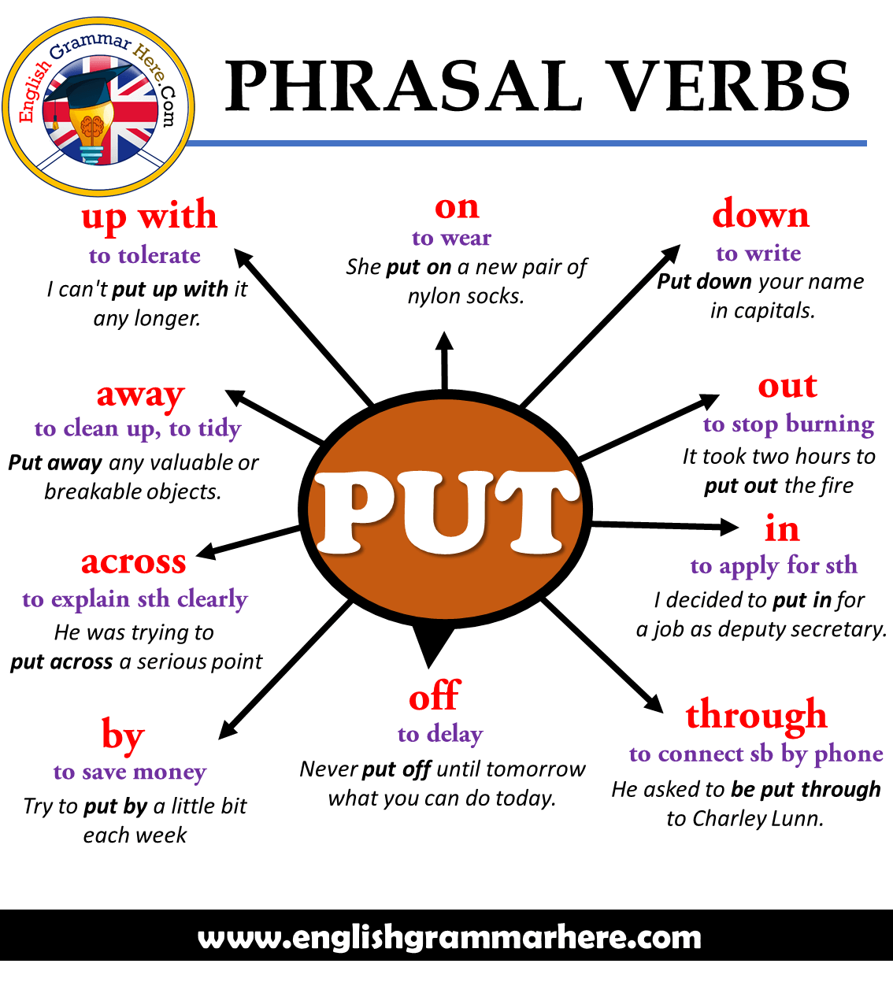 | The aim: To develop pupils speaking skills and create friendly atmosphere  Efficiency: By wishing each other they feel better and feel the support of others  Students of the class are listed.  Students' attention is drawn to the lesson.  Determines the topic and purpose of the lesson  Students say different words from the picture | The teacher to assess learners for their ability.  “Good job!  Well done!”  Formative Assessment  Good job!  Assessment criteria  - Learners have met the learning objectives if they can: Talk about | Pictures  worksheet  Student’s book
Middle of the lesson  Presentation part.  30 min | Ex:4 P:47  • Present and practise prepositional phrases Explain the task and give Ss some time to complete it then check Ss’ answers.  Ex: 5 P: 47  • Listen for specific information  • Explain the task and ask Ss to read the statements 1-7 and underline what they think are the key words that will help them to complete the task.  • Play the audio and give Ss time to complete the task and then check their answers.  Ex: 6 P: 47  • Consolidate information in a text; to express a personal opinion  • Ask Ss to talk in pairs about how the information in the text can help them personally.  • Ask various Ss to tell the class.  Conclusion during the lesson some tasks differentiated by outcomes of the students and by their abilities. | Pupils complete with: on, at (x2), to, in.  ANSWERS  1 on 2 in 3 at 4 at 5 to  Pupils will hear a dialogue. Decide which of the statements (1-7) are T (true), F (false) or DS (doesn’t say).  ANSWERS  1 DS 3 T 5 T 7 F 2 F 4 F 6 DS  Pupils answer the question. Tell your partner.  ANSWERS  Exercise produces chemicals that can make you feel happy and calm, and help you to concentrate. This would help me because I have a lot of exams to study for this year and I get stressed. | Descriptor:  - complete with preposition  Total: 3 point  pupils are evaluated by collecting vitamins  Descriptor:  - read the dialogue  - Decide which of the statements  Total: 3 point  Descriptor:  - answer the question  - tell your partner.  Total: 3 point  -Make CCQ questions Yes / No  Total: 10 point | Card  Worksheet  Students book
End of the lesson  5 min | FEEDBACK  Learners provide feedback on what they have learned at the lesson.  Ex:  Home task: |  |  | Poster Success

Unit: Sport, Health & Exercise |  | Lesson 19
Teacher name: Zhexenbina A.A |  | School of Oriental Studies at Kazakh National University named after al-Farabi
Date: 06.02.2024
Grade: 8 Б |  | Number present: | absent:
Lesson title | Everyday English: Asking for / giving advice
Learning objectives | 8.1.10.1 use talk or writing as a means of reflecting on and exploring a range of perspectives on the world  8.3.7.1 use appropriate subject-specific vocabulary and syntax to talk about a range of general topics, and some curricular topics  8.4.1.1 understand the main points in texts on a growing range of unfamiliar general and curricular topics, including some extended texts
Lesson objectives | Learners will be able to:  - respond adequately to personal questions in a variety of situations and contexts (e.g. in interviews and dialogues)  - identify and interpret the author’s tone/opinion at basic level
Value links | Open-Mindedness – An open-minded person is someone who is always willing to hear new points of view and even change their own point of view if new arguments are highly convincing. It’s the opposite of stubbornness.
Plan

Stages / Time | Teachers actions | Students actions | Assessment criteria | Resources
Beginning of the lesson  Warming-up  3 min  Pre-learning  «Brainstorming» method  7 min. | Organization moment :  1.Greeting.  Ask about the weather.  The teacher sets the lesson objectives, letting students know what to anticipate from the lesson.  Warming up  Hot Potato  Students stand in a circle and pass an object around. When the timer goes off, or the music stops, the student holding the hot potato has to do something.  Lead – In  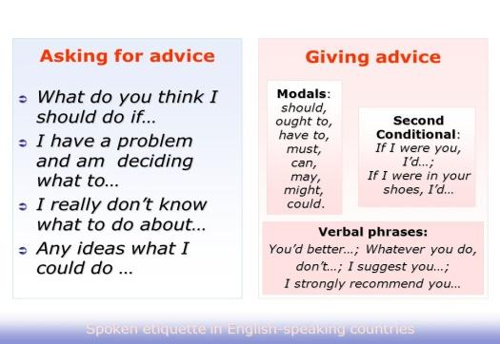 | The aim: To develop pupils speaking skills and create friendly atmosphere  Efficiency: By wishing each other they feel better and feel the support of others  Students of the class are listed.  Students' attention is drawn to the lesson.  Determines the topic and purpose of the lesson  Students say different words from the picture | The teacher to assess learners for their ability.  “Good job!  Well done!”  Formative Assessment  Good job!  Assessment criteria  - Learners have met the learning objectives if they can: Talk about | Pictures  worksheet  Student’s book
Middle of the lesson  Presentation part.  30 min | Ex:1 P:48  • Practise pronunciation of situational language  • Play the recording. Ss listen and repeat chorally and/or individually.  • Pay attention to Ss’ pronunciation and intonation and correct as necessary.  Ex: 2 P: 48  • Listen and read for gist  • Refer Ss to the sentences in Ex. 1 again and elicit Ss’ guesses as to what the dialogue is about.  • Play the recording. Ss listen and read the text to find out.  Ex: 3 P: 48  • Read for specific information Give Ss time to read the dialogue again and then elicit answers to the questions.  Ex: 4 P: 48  • Learn synonymous phrases Read out the phrases. Refer Ss back to the dialogue and elicit the synonymous ones from various Ss around the class.  Conclusion during the lesson some tasks differentiated by outcomes of the students and by their abilities. | Pupils listen and repeat.  ANSWERS  Students own answer  Pupils read the dialogue between two friends  ANSWERS  The dialogue is about someone advising a friend who wants to keep fit without spending a lot of money.  Pupils read the dialogue. What does Asyl advise Kate to do? What pros and cons of exercising at home do the speakers mention?  ANSWERS  Asyl advises Kate to exercise at home. The pros are it saves money and time and the cons are that you can’t use a variety of equipment and it’s easier to get an injury without a trainer.  Pupils find sentences in the dialogue  ANSWERS  What do you think I should do? = Any ideas? Have you considered exercising at home? = Have you thought about exercising at home? I don’t think it’s a good idea. = I’m not sure that’s such a good idea. I don’t have enough money at the moment. = I can’t afford it right now. | Descriptor:  - listen and repeat  Total: 3 point  pupils are evaluated by collecting vitamins  Descriptor:  - read the dialogue  between two friends  Total: 3 point  Descriptor:  - read the dialogue  -answer the question  Total: 3 point  Descriptor:  - find sentences in the dialogue  Total: 3 point  -Make CCQ questions Yes / No  Total: 10 point | Card  Worksheet  Students book
End of the lesson  5 min | FEEDBACK  Learners provide feedback on what they have learned at the lesson.  Ex:  Home task: |  |  | Poster Success

Unit: Grammar: will/ be going to |  | Lesson 20
Teacher name: Zhexenbina A.A |  | School of Oriental Studies at Kazakh National University named after al-Farabi
Date: 13.02.2024
Grade: 8 Б |  | Number present: | absent:
Lesson title | Across cultures:  Summative Assessment for the unit 4
Learning objectives | 8.1.5.1 use feedback to set personal learning objectives  8.6.7.1 use a variety of simple perfect forms to express recent, indefinite and unfinished past on a range of familiar general and curricular topics  8.5.7.1 use with minimal support appropriate layout at text level for a range of written genres on familiar general and curricular topics
Lesson objectives | Learners will be able to:  - differentiate and use the meaning, parts of speech and word  - identify the central idea, the intended audience and the author’s purpose  - organise ideas appropriately for both purpose and reader (e.g. captions; headings; bullet points; fonts; chapters; letter formats; paragraphs)
Value links | Open-Mindedness – An open-minded person is someone who is always willing to hear new points of view and even change their own point of view if new arguments are highly convincing. It’s the opposite of stubbornness.
Plan

Stages / Time | Teachers actions | Students actions | Assessment criteria | Resources
Beginning of the lesson  Warming-up  3 min  Pre-learning  «Brainstorming» method  7 min. | Organization moment :  1.Greeting.  Ask about the weather.  The teacher sets the lesson objectives, letting students know what to anticipate from the lesson.  Warming up  Hot Potato  Students stand in a circle and pass an object around. When the timer goes off, or the music stops, the student holding the hot potato has to do something.  Lead – In | The aim: To develop pupils speaking skills and create friendly atmosphere  Efficiency: By wishing each other they feel better and feel the support of others  Students of the class are listed.  Students' attention is drawn to the lesson.  Determines the topic and purpose of the lesson  Students say different words from the picture | The teacher to assess learners for their ability.  “Good job!  Well done!”  Formative Assessment  Good job!  Assessment criteria  - Learners have met the learning objectives if they can: Talk about s Dmitry Balandin | Pictures  worksheet  Student’s book
Middle of the lesson  Presentation part.  30 min | Ex:1 P: 49  • Introduce the topic and predict the content of a text  • Ask Ss to look at the pictures and then ask Ss to discuss the questions in pairs.  • Elicit answers from Ss around the class.  Ex: 2 P: 49  • Listen and read for specific information  • Elicit what if anything Ss know about the athletes an then elicit various questions from Ss around the class and write two of them on the board.  • Play the recording. Ss listen and read to see if they can answer the questions.  Ex: 3 P: 49  • Read for specific information  • Ask Ss to copy the table into their notebooks and then give them time to complete it with information from the text.  • Ask various Ss to use their completed table to present the athletes to the class.  Summative Assessment for the unit 4  Conclusion during the lesson some tasks differentiated by outcomes of the students and by their abilities. | Pupils look at the title and the pictures. Answer the question  ANSWERS  A: I think they won Olympic medals in swimming.  B: Me too. I think they felt very proud.  Pupils listen, read and check if you can answer your questions. Write a few questions.  ANSWERS  Where are they from? (Dmitriy Balandin is from Kazakhstan and Adam Peaty is from Great Britain.) Where did they win their medals? (Rio)  Pupils copy and complete the table with information from the text. Then present the two athletes to the class.  ANSWERS | Descriptor:  - look at the title and the pictures  - answer the question  Total: 3 point  pupils are evaluated by collecting vitamins  Descriptor:  - listen, read and check  - answer your questions  - write a few questions.  Total: 3 point  Descriptor:  - copy and complete the table with  Total: 3 point  -Make CCQ questions Yes / No  Total: 10 point | Card  Worksheet  Students book
End of the lesson  5 min | FEEDBACK  Learners provide feedback on what they have learned at the lesson.  Ex:  Home task: |  |  | Poster Success

Unit: Asking for/giving advice |  | Lesson 21
Teacher name: Zhexenbina A.A |  | School of Oriental Studies at Kazakh National University named after al-Farabi
Date: 20.02.2024
Grade: 8 Б |  | Number present: | absent:
Lesson title | Across curriculum: Muscles
Learning objectives | 8.5.1.1 plan, write, edit and proofread work at text level with little support on a range of general and curricular topics  8.4.1.1 understand the main points in texts on a growing range of unfamiliar general and curricular topics, including some extended texts  8.3.7.1 use appropriate subject-specific vocabulary and syntax to talk about a range of general topics, and some curricular topics
Lesson objectives | Learners will be able to:  - check their own and others’ writing to ensure that it communicates what they intended and improve the writing if needed  - identify the central idea, the intended audience and the author’s purpose
Value links | Open-Mindedness – An open-minded person is someone who is always willing to hear new points of view and even change their own point of view if new arguments are highly convincing. It’s the opposite of stubbornness.
Plan

Stages / Time | Teachers actions | Students actions | Assessment criteria | Resources
Beginning of the lesson  Warming-up  3 min  Pre-learning  «Brainstorming» method  7 min. | Organization moment :  1.Greeting.  Ask about the weather.  The teacher sets the lesson objectives, letting students know what to anticipate from the lesson.  Warming up  Hot Potato  Students stand in a circle and pass an object around. When the timer goes off, or the music stops, the student holding the hot potato has to do something.  Lead – In  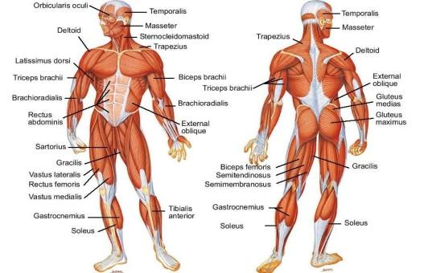 | The aim: To develop pupils speaking skills and create friendly atmosphere  Efficiency: By wishing each other they feel better and feel the support of others  Students of the class are listed.  Students' attention is drawn to the lesson.  Determines the topic and purpose of the lesson  Students say different words from the picture | The teacher to assess learners for their ability.  “Good job!  Well done!”  Formative Assessment  Good job!  Assessment criteria  - Learners have met the learning objectives if they can: Talk about the changing classroom | Pictures  worksheet  Student’s book
Middle of the lesson  Presentation part.  30 min | Ex:1 P: 50  • Introduce the topic; to read for specific information  • Read the rubric aloud.  • Give Ss time to read the text and find out about which type of muscles we use for the actions listed.  Ex: 2 P: 50  • Read for cohesion and coherence • Ask Ss to read the text again and for each gap (1-7) choose from the options (1-4).  • Allow Ss time to complete the task and then ask them to check their answers with their partner.  Ex: 3 P: 50  • Consolidate vocabulary and information in a text  • Allow Ss time to look up the meanings of the words in bold in the text using their dictionaries as necessary.  • Then ask Ss to ask and answer comprehension questions about the information in the text in pairs.  Ex: 4 P: 50  • Give a presentation on muscles  • Ask Ss to copy the headings into their notebooks.  • Play the recording and ask Ss to listen and read the text and make notes under the headings.  • Then ask individual Ss to come up in front of the class and give a short presentation on muscles using their notes.  Conclusion during the lesson some tasks differentiated by outcomes of the students and by their abilities. | Pupils read through to find out. Answer the question  ANSWERS  We can control all of these movements, so we use skeletal muscles, which are also called voluntary muscles.  Pupils read the text and, for each gap, choose the correct word (A-D). Compare answers with your partner.  ANSWERS  1 D 3 D 5 A 7 B 2 C 4 B 6 C  Pupils explain the words in bold. Then, in pairs, ask and answer questions based on the text.  ANSWERS  digest (v) = when the stomach changes food into substances the body can use  nerves (n) = long thin fibres that carry information to and from the brain  hormones (n) = chemicals in the blood that control different processes in the body  attached (adj) = being fastened/connected to  Pupils read and listen to the text. Make notes under the headings:  ANSWERS  Why we need muscles for everything we do (except thinking) We need them to move in any way; to sit, talk, write, read, breathe, digest food, and for our hearts to beat.  what muscles are made of bundles of elastic tissue  what types of muscles there are skeletal muscle, smooth muscle and cardiac muscle | Descriptor:  - read through to find out.  - answer the question  Total: 3 point  pupils are evaluated by collecting vitamins  Descriptor:  - read the text  - choose the correct word  Total: 3 point  Descriptor:  - explain the words in bold  - ask and answer questions based on the text.  Total: 3 point  Descriptor:  - read and listen to the text  - make notes under the headings  Total: 3 point  -Make CCQ questions Yes / No  Total: 10 point | Card  Worksheet  Students book
End of the lesson  5 min | FEEDBACK  Learners provide feedback on what they have learned at the lesson.  Ex:  Home task: |  |  | Poster Success

Unit: Muscles |  | Lesson 22
Teacher name: Zhexenbina A.A |  | School of Oriental Studies at Kazakh National University named after al-Farabi
Date: 27.02.2024
Grade: 8 Б |  | Number present: | absent:
Lesson title | Summative assessment term 2
Learning objectives | 8.5.1.1 plan, write, edit and proofread work at text level with little support on a range of general and curricular topics  8.3.3.1 give an opinion at discourse level on a wide range of general and curricular topics  8.2.1.1 understand with little or no support the main points in extended talk on a wide range of general and curricular topics
Lesson objectives | Learners will be able to:  - check their own and others’ writing to ensure that it communicates what they intended and improve the writing if needed  - identify the central idea, the intended audience and the author’s purpose
Value links | Open-Mindedness – An open-minded person is someone who is always willing to hear new points of view and even change their own point of view if new arguments are highly convincing. It’s the opposite of stubbornness.
Plan

Stages / Time | Teachers actions | Students actions | Assessment criteria | Resources
Beginning of the lesson  Warming-up  3 min  Pre-learning  «Brainstorming» method  7 min. | Organization moment :  1.Greeting.  Ask about the weather.  The teacher sets the lesson objectives, letting students know what to anticipate from the lesson.  Warming up  Hot Potato  Students stand in a circle and pass an object around. When the timer goes off, or the music stops, the student holding the hot potato has to do something.  Lead – In | The aim: To develop pupils speaking skills and create friendly atmosphere  Efficiency: By wishing each other they feel better and feel the support of others  Students of the class are listed.  Students' attention is drawn to the lesson.  Determines the topic and purpose of the lesson  Students say different words from the picture | The teacher to assess learners for their ability.  “Good job!  Well done!”  Formative Assessment  Good job!  Assessment criteria  - Learners have met the learning objectives if they can: Talk about the | Pictures  worksheet  Student’s book
Middle of the lesson  Presentation part.  30 min | Listening  Task. Listen to the recording about Schumacher’s career. Write to what people and events these numbers and dates refer to.  Ttranscript for listening task can be found after the mark scheme.  Example: 1977 car accident with Jacques Villeneuve at Grand Prix  1. 4 March ___________________  2. £1.3 million _________________  3. 1994 ____________________  4. 1999 ______________________  5. over 1.5 seconds ____________  6. 18 March _________________  Reading  Task. Read the statements, decide if they are TRUE or FALSE and explain your choice.  Read the article and write the answers from the text.  Writing  Task. Choose ONE of the topics to write  Speaking  Task. Work in pairs. Choose one of the cards and answer the questions. You have 1 minute to prepare and 3 minutes to speak. While speaking do not forget to use topic related vocabulary. Show interaction asking and answering questions.  Conclusion during the lesson some tasks differentiated by outcomes of the students and by their abilities. | Pupils listen to the recording about Schumacher’s career  ANSWERS  write their answers using their own words with the correct information from the monologue  Pupils read the statements, decide if they are TRUE or FALSE  ANSWERS  True. Explanation: Advertising influences children’s choice of toys.  False. Explanation: Another influence advertising has had is on the clothes children want to wear.  False. Explanation: Companies use cartoon characters to influence on children.  Pupils choose ONE of the topics to write  ANSWERS  Students own answer  Pupils work in pairs. Choose one of the cards and answer the questions  ANSWERS  Students own answer | Descriptor:  - listen to the recording about Schumacher’s career  Total: 6 point  pupils are evaluated by collecting vitamins  Descriptor:  - read the statements  Total: 6 point  Descriptor:  - choose ONE of the topics  Total: 6 point  Descriptor:  - work in pairs.  - choose one of the cards and answer the questions  Total: 6 point  -Make CCQ questions Yes / No  Total: 10 point | Card  Worksheet  Students book
End of the lesson  5 min | FEEDBACK  Learners provide feedback on what they have learned at the lesson.  Ex:  Home task: |  |  | Poster Success

Unit: Edutainment 4 |  | Lesson 23
Teacher name: Zhexenbina A.A |  | School of Oriental Studies at Kazakh National University named after al-Farabi
Date: 05.03.2024
Grade: 8 Б |  | Number present: | absent:
Lesson title | Writing: a for and against essay
Learning objectives | 8.3.7.1 use appropriate subject-specific vocabulary and syntax to talk about a range of general topics, and some curricular topics  8.4.2.1 understand specific information and detail in texts on a growing range of familiar general and curricular topics, including some extended texts  8.6.15.1 use infinitive forms after a limited number of verbs and adjectives; use gerund forms after a limited variety of verbs and prepositions; use some prepositional verbs and begin to use common phrasal verbs on a growing range of familiar general and curricular topics
Lesson objectives | Learners will be able to:  - check their own and others’ writing to ensure that it communicates what they intended and improve the writing if needed  - identify the central idea, the intended audience and the author’s purpose
Value links | Open-Mindedness – An open-minded person is someone who is always willing to hear new points of view and even change their own point of view if new arguments are highly convincing. It’s the opposite of stubbornness.
Plan

Stages / Time | Teachers actions | Students actions | Assessment criteria | Resources
Beginning of the lesson  Warming-up  3 min  Pre-learning  «Brainstorming» method  7 min. | Organization moment :  1.Greeting.  Ask about the weather.  The teacher sets the lesson objectives, letting students know what to anticipate from the lesson.  Warming up  Hot Potato  Students stand in a circle and pass an object around. When the timer goes off, or the music stops, the student holding the hot potato has to do something.  Lead – In  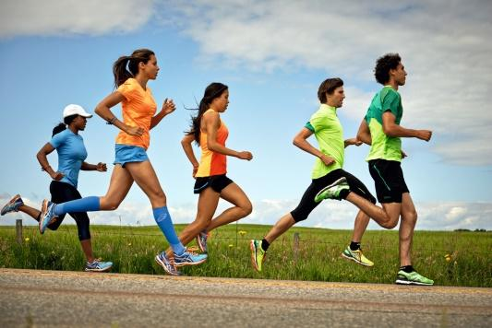 | The aim: To develop pupils speaking skills and create friendly atmosphere  Efficiency: By wishing each other they feel better and feel the support of others  Students of the class are listed.  Students' attention is drawn to the lesson.  Determines the topic and purpose of the lesson  Students say different words from the picture | The teacher to assess learners for their ability.  “Good job!  Well done!”  Formative Assessment  Good job!  Assessment criteria  - Learners have met the learning objectives if they can: Talk about the | Pictures  worksheet  Student’s book
Middle of the lesson  Presentation part.  30 min | Ex:1 P: 51  • Introduce the topic and read for specific information  • Read out the title of the essay. Ask Ss to think of two reasons for and two against exercising in groups.  • Give Ss time to read the essay and then check if their reasons are mentioned.  Ex: 2 P: 51  • Read for structure  • Ask Ss to read the essay and identify the paragraphs that contain the items mentioned.  • Check Ss’ answers.  Ex: 3 P: 51  • Substitute linking words/phrases for suitable alternatives  • Ask Ss to read the Study Skills box.  • Direct Ss to the underlined linking words/phrases in the text and give Ss time to complete the task.  • Then elicit answers from various Ss.  Ex: 4 P: 52  • Match arguments and justifications/examples and identify pros/cons  • Ask Ss to read the table and then give them time to match the arguments with the justifications/ examples.  • Check Ss’ answers and then elicit which ones are pros/cons.  Conclusion during the lesson some tasks differentiated by outcomes of the students and by their abilities. | Pupils read the title of the essay. Think of two reasons for and two reasons against exercising in groups. Read the essay and check if your ideas are mentioned.  ANSWERS  Reasons for: Make new friends (mentioned) Improve your social life (mentioned)  Reasons against: Get left behind (mentioned) Peer pressure (not mentioned)  Pupils answer the question  ANSWERS  The writer’s opinion – 4 A presentation of the topic – 1  Pupils replace the underlined linking words/phrases in the text with synonyms from the Study Skills box.  ANSWERS  To begin with = Firstly  Also = In addition  For example = For instance  On the other hand = However  Firstly = To start with  As a result = Consequently  Secondly = Furthermore On the whole = All in all  Pupils match the arguments for-and-against exercising at a gym to their justifications/examples. Decide which of the arguments are pros and which are cons.  ANSWERS  1 A 2 C 3 B 4 D  Pros = 1, 3  Cons = 2, 4 | Descriptor:  - read the title of the essay  - read the essay and check if your ideas are mentioned.  Total: 3 point  pupils are evaluated by collecting vitamins  Descriptor:  - answer the question  Total: 3 point  Descriptor:  - replace the underlined linking words/phrases in the text with synonyms  Total: 3 point  Descriptor:  - match the arguments for-and-against  Total: 3 point  -Make CCQ questions Yes / No  Total: 10 point | Card  Worksheet  Students book
End of the lesson  5 min | FEEDBACK  Learners provide feedback on what they have learned at the lesson.  Ex:  Home task: |  |  | Poster Success

Unit: Reading for pleasure |  | Lesson 24
Teacher name: Zhexenbina A.A |  | School of Oriental Studies at Kazakh National University named after al-Farabi
Date: 12.03.2024
Grade: 8 |  | Number present: | absent:
Lesson title | Edutainment
Learning objectives | 8.1.3.1 respect differing points of view  8.3.5.1 interact with peers to negotiate, agree and organise priorities and plans for completing classroom tasks
Lesson objectives | Learners will be able to:  - demonstrate understanding of multiple perspectives through reflection and paraphrasing
Value links | Open-Mindedness – An open-minded person is someone who is always willing to hear new points of view and even change their own point of view if new arguments are highly convincing. It’s the opposite of stubbornness.
Plan

Stages / Time | Teachers actions | Students actions | Assessment criteria | Resources
Beginning of the lesson  Warming-up  3 min  Pre-learning  «Brainstorming» method  7 min. | Organization moment :  1.Greeting.  Ask about the weather.  The teacher sets the lesson objectives, letting students know what to anticipate from the lesson.  Warming up  Hot Potato  Students stand in a circle and pass an object around. When the timer goes off, or the music stops, the student holding the hot potato has to do something.  Lead – In | The aim: To develop pupils speaking skills and create friendly atmosphere  Efficiency: By wishing each other they feel better and feel the support of others  Students of the class are listed.  Students' attention is drawn to the lesson.  Determines the topic and purpose of the lesson  Students say different words from the picture | The teacher to assess learners for their ability.  “Good job!  Well done!”  Formative Assessment  Good job!  Assessment criteria  - Learners have met the learning objectives if they can: Talk about fitness | Pictures  worksheet  Student’s book
Middle of the lesson  Presentation part.  30 min | Ex:1 a P: 52  • Learn about the value of fitness and personalise the topic  • Ask Ss to read the list of statements about fitness and tick the ones that apply to them.  Ex: 1 b P: 52  • Discuss the value of fitness Ask Ss to discuss the question in pairs and then ask some Ss to share their answers with the rest of the class.  Ex: 2 P: 52  • Test knowledge learnt in this module/ to do a quiz  • Explain the task. Allow Ss some time to read the statements and mark them as true or false.  • Tell Ss they can review the module and find the relevant information to help them if necessary.  • Check Ss’ answers.  Ex: 3 P: 52  • Consolidate vocabulary learnt in the module/to write a quiz  • Explain the task and allow Ss time to work in pairs and look through the module and think of quiz questions.  • Tell Ss they can use the quiz in the previous task as a model. Offer an example (e.g. Quidditch comes from the Harry Potter books. [T])  • Ss can swap their quiz with another pair and do it and then report back to the class.  Conclusion during the lesson some tasks differentiated by outcomes of the students and by their abilities. | Pupils read the statements below. Tick (✓) the ones that are true for you.  ANSWERS  Students own answer  Pupils tell the class. Answer the question  ANSWERS  I think it’s important to exercise because you need to get your body fit and healthy. When you don’t exercise, you are more likely to develop a disease.  Pupils do the quiz. Decide if the sentences are T (true) or F (false).  ANSWERS  1 F 3 T 5 T 7 T 2 F 4 F 6 F 8 T  Pupils go through Module 4 and write a T/F quiz of your own.  ANSWERS  1 There are seven players in a Quidditch team. [T]  2 Sepak Takraw comes from Malaysia. [T]  3 Exercise builds up stress. [F]  4 Exercise burns fat and builds muscle. [T]  5 Dmitriy Balandin was born in 1995. [T]  6 Adam Peaty always loved being in the water. [F]  7 Both Dmitriy and Adam won gold medals in Rio. [T]  8 Smooth muscles are voluntary muscles. [F] | Descriptor:  - read the statements  - tick (✓) the ones that are true  Total: 3 point  pupils are evaluated by collecting vitamins  Descriptor:  - tell the class  - answer the question  Total: 3 point  Descriptor:  - do the quiz  - decide if the sentences  Total: 3 point  Descriptor:  - write a T/F quiz of your own.  Total: 3 point  -Make CCQ questions Yes / No  Total: 10 point | Card  Worksheet  Students book
End of the lesson  5 min | FEDBACK  Learners provide feedback on what they have learned at the lesson.  Ex:  Home task: |  |  | Poster Success

